Transcultural musicians discussed their situation in Finland
In Living Room Session organised by Global Music Centre on Monday 14.4.2014 transcultural musicians discussed their current situation in Finland.
Even for musicians who had a great career in their home countries, there seems to be no possibilities in gaining income as musicians or getting any kind of media visibility for their work. One after another the musicians told about losing their band members one by one as no payments could be paid for their performances.

Who could amplify the voices of different musical genres?
Famous Senegalese mbalax musician Pape Sarr, in Finland the director of Galaxy world music band, stated that the situation especially in the media programming has only gotten worse during the years he has spent in Finland. The amount of hours for alternative musical genres in both radio and TV programming has decreased considerably. The observation was confirmed by the director of Global Music Centre, Jaana-Maria Jukkara.
Several questions were raised at the meeting: Is it really good for Finland to have world musicians of international quality working as taxi drivers? Do the Finland-based world music bands have to go Estonia to get recognised? Should the transcultural musicians form their own alliance to get their voice heard in Finland? And even so, who could really amplify their voices?
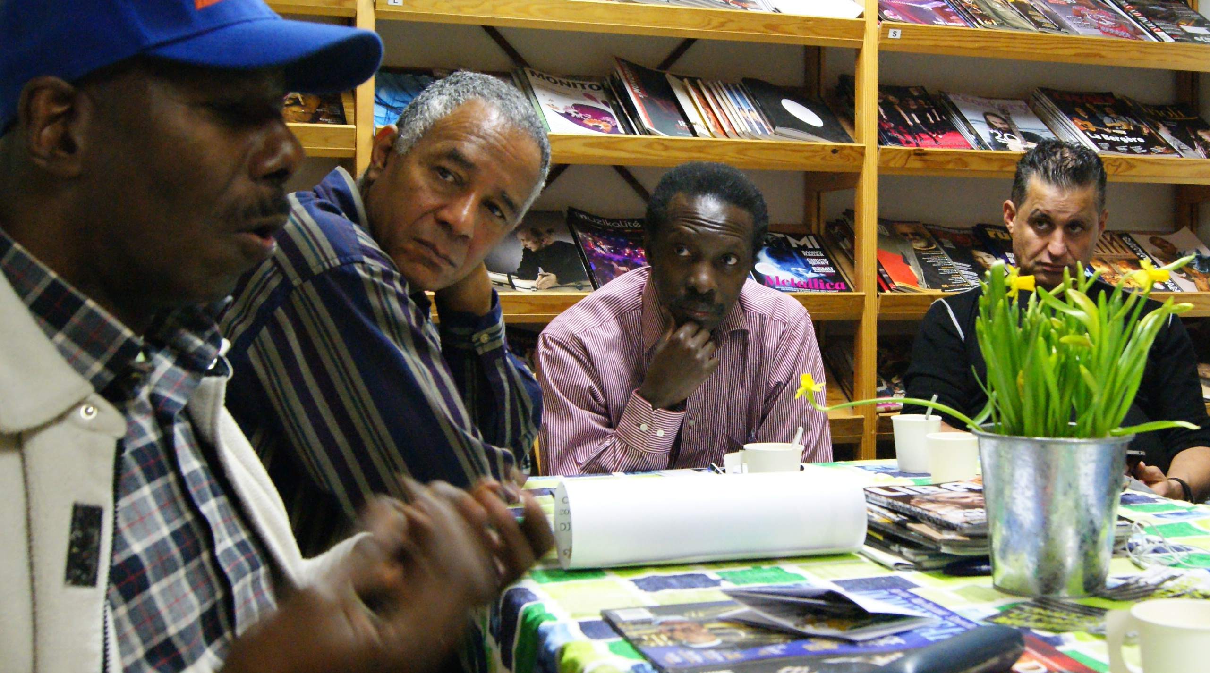

What happens with the promotion?
In the level of cultural policies, a question about the promotion was raised. Music promotion seems to be a field where there is either little expertise or no possibilities of earning income in Finland. Flamenco musician Jonas Widenius stated that many of the bigger bands find their agents from abroad. Would it be possible to employ British or Swedish music promoters to rescue the rich field of world music in Finland that seems to be sinking in its invisibility? Questions of promotion were directed also to Arts Promotion Centre.
Viivi Seirala, special adviser, and Outi Korhonen, regional artist on cultural diversity, answered the questions on behalf of the Arts Promotion Centre. Even though the name of the institution is Arts Promotion Centre, this expert agency under the Ministry of Education and Culture mainly concentrates on processing the grants and subsidies. Viivi Seirala told about the support that the Arts Promotion Centre can offer. Outi Korhonen talked also about other foundations and about the work that Catalysti association is doing. Some musicians stated that aspects of promotion and lobbying the transcultural musicians cause were not well enough responded. “We do not want a person, we want a concrete, stable structure”, stated reggae musician Mike Thomas, also known as Saganor. Obi Phrase, a reggae musician from Sierra Leone, emphasized the need for creating a transcultural artists consortium.
Transcultural artists who act for their cause have succeeded to make some influence eg. in the work of Catalysti association of transcultural artists and Sivuvalo project that works for the cause of multilingual writers. Catalysti ry is also open for musicians. In projects related to Taike and transcultural musicians, the high quality of foreign-born musicians resident in Finland has become evident in the Maa ilmassa world club series organised at Stoa and Vuotalo. However, from the point of view of the artists individual gigs do not bring significant relief for the situation. A touring structure for world musicians in Finland would thus be one of the important next steps.
After the conversation it was initially agreed to organize an event that aims to pluralize the music programming in Finland together with Cultural Centre Caisa. More information of this will be given later.
Text and photos by Outi Korhonen

