http://www.wjla.com/articles/2012/01/new-gallaudet-building-to-be-model-for-deaf-architecture-71802.html

New Gallaudet building to be model for deaf architecture
By Pamela Brown
January 24, 2012 - 05:18 pm
It might look like just a regular building under construction. But to Gallaudet University students like Colin Whited, it's a place they can call their own.
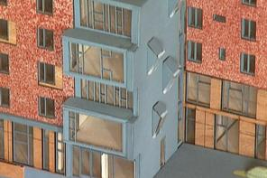
An image of the new building (Photo: WJLA)
“They really handed over the ball,” Whited says. “That had never happened in the past.”
The state-of-the-art building, based on the vision of students and faculty, is designed to make it easier for signers to communicate and understand their surroundings.
“It's incredible because typically those who design buildings don't understand our desires... as deaf people,” says one.
Out of those dreams, deafspace was born.
The new architecture will have sloping sidewalks, wider stairs and hallways and rounded corners - all to make it easier for signers to maintain uninterrupted eye-to-eye communication. To heighten sensory awareness, special lighting and color contrasts are strategically used.
The building is expected to be completed in the summer and will be ready for Gallaudet students by the fall.
Architect Hansel Bauman says vibration awareness is another key component
“You can rap on a table, instigate you want to communicate, the awareness of the vibration, that's what’s unique,” Bauman says.
One room, dubbed Colab, will remain in its current form to inspire creativity. And then there's the social space - a wide open room to promote more student interaction that is unlike anything Gallaudet has had before.
Deafspace specialist Robert Sirvage, says the building is an expression of his culture.
“We are the only ones who know what we need,” Sirvage says.
Whited says he hopes this "first-of-its-kind" dorm will become the new norm.
"This is groundbreaking,” Whited says. “Sets the tone for deaf architecture."

