Accessibility and diversity checklist for museums

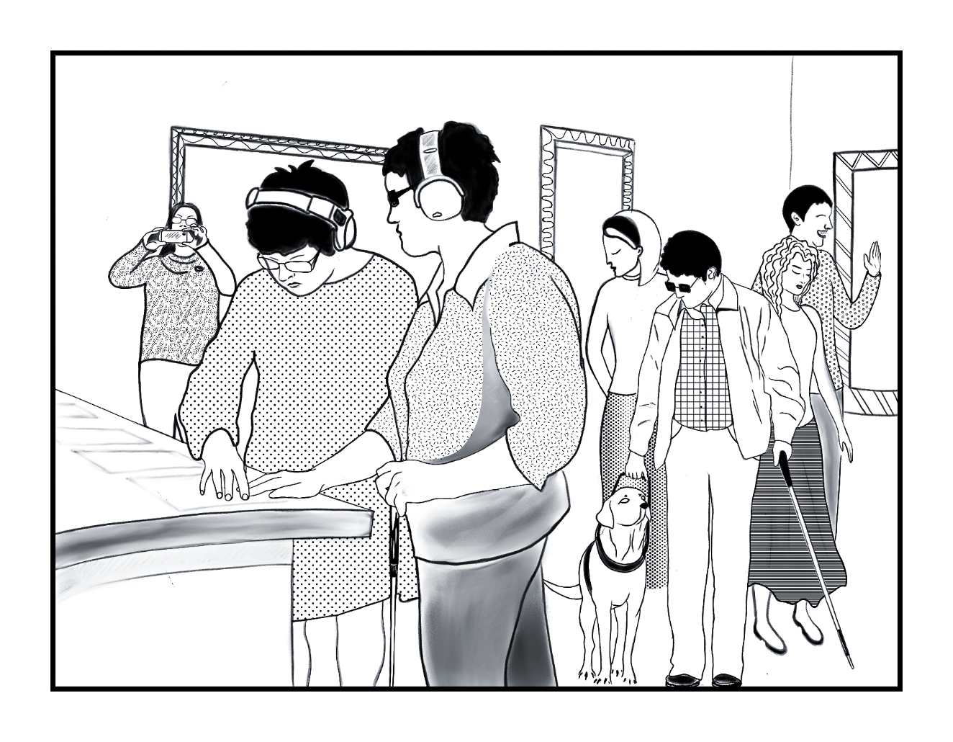

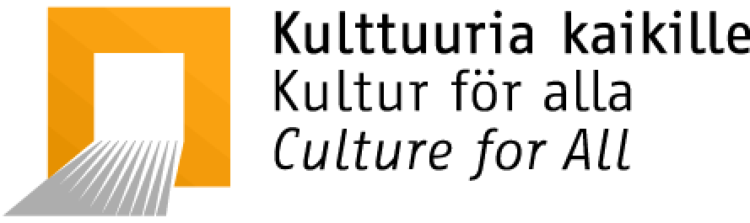 

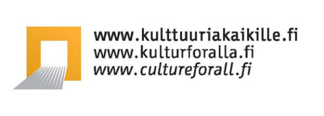 



Accessibility and diversity checklist for museums

Publication of Culture for All Service 1/2022

Editors: Outi Salonlahti and Sari Salovaara

Authors: Christine Langinauer, Aura Linnapuomi, Martina Marti, Outi Salonlahti and Sari Salovaara

Translation: Susan Heiskanen

Proofreading of the English version: Arlene Tucker, Rita Paqvalén, Aura Linnapuomi, Sari Salovaara and Outi Salonlahti

Publishers: Culture for All Service / For Culture on Equal Terms and The Finnish National Committee of ICOM

Graphic design on PDF version: Re:Start (working group) [restart.metropolia.fi](http://restart.metropolia.fi/)

Layout of the PDF version: Aino Valkamo, [react.metropolia.fi](http://react.metropolia.fi)

Illustrations: Kristina Vasileva

1. Edition

ISBN 978-952-6677-75-0 (PDF)

ISBN 978-952-6677-76-7 (DOCX)

ISSN 2341-913X



The text of this publication has been licensed under the Creative Commons Attribution-NonCommercial-NoDerivatives 4.0 International license. For more, go to [creativecommons.org/licenses/by-nc-nd/4.0](https://creativecommons.org/licenses/by-nc-nd/4.0)

The Creative Commons license does not apply to the illustrations and graphic design of the publication. The illustration and graphic design are under copyright.

Contents

Introduction 5

How to use this checklist 5

What does accessibility mean for museums? 6

What does paying attention to diversity at museums mean? 7

Checklist areas 8

Acknowledgements 8

1 Strategic work and personnel 10

2 Budgeting and procurements 15

2.1 Budgeting 15

2.2 Procurements and outsourced services 16

2.3 ICT purchases, such as websites and mobile applications 17

3 Exhibition contents, collections and archives 21

4 Public programming and audience engagement 24

4.1 Guided tours and workshops 26

4.2 Events 28

5 Customer service 31

5.1 Training and introduction for the customer service staff 31

5.2 Language and communications 33

5.3 Service 34

5.4 Assistance 35

5.5 Assistive devices and accessibility solutions 36

5.6 Exhibition supervision 37

6 Pricing 39

7 Communications 43

7.1 Language options and Easy Language 44

7.2 Graphic design 45

7.3 Accessibility information and other central information 46

7.4 Information for different senses 48

7.5 Diversity and avoiding stereotypes 48

7.6 Website 49

Assessment and testing 50

Clarity of the website 51

Links and text alternatives for images 52

Website properties 53

Files, videos and forms at the website 56

7.7 Online newsletters and stores 58

8 Museum area, spaces and facilities 59

8.1 Coming to the museum 59

8.2 Signs 60

8.3 Getting around on the museum premises 61

8.4 The sensory environment 63

8.5 Exhibition construction 66

8.6 Exhibition texts 67

8.7 Accessibility in the museum’s emergency plan 68

Glossary 70

Accessibility 70

Accessibility Act 70

Accompanying persons, personal assistants and interpreters 71

Act on the Provision of Digital Services 71

Audio description 71

Captions / Subtitles 72

Cultural sensitivity 72

Culture Pilots/Culture Companions 72

Directive on the accessibility of websites and mobile applications 73

Disability 73

Diversity 73

Easy language 74

Equality 74

Equity 74

Hearing induction loop 74

Inclusion 75

Non-Discrimination 76

Non-Discrimination Act 76

Norms 76

Reasonable adjustments 77

Safer spaces / principles for a safer space 78

Services in sign language and services interpreted into sign language 78

Social Story 79

Speech-to-Text interpretation 79

Stereotypes 79

Text alternative / Alt text 80

Verbal map 80

WCAG 2.1 / Web Content Accessibility Guidelines 80

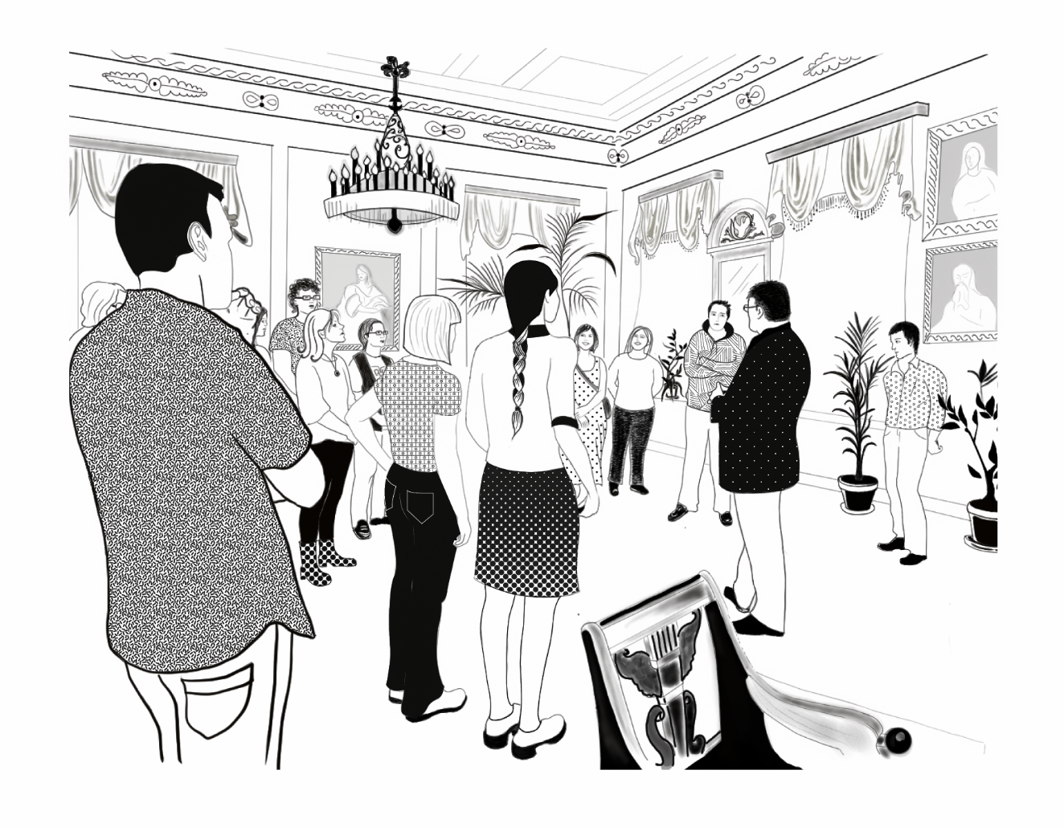

# Introduction

The purpose of this checklist is to help museums to independently evaluate and develop their operations and services. By paying attention to accessibility and diversity in all their operations, museums can become comfortable and meaningful places in their full potential.

This checklist is an update and extension to the publication Museoiden esteettömyyden tarkistuslista (Sari Salovaara and Tuuli Rajavuori / Culture for All Service 2004).

## How to use this checklist

This checklist serves as a to-do-list, a tool to support the development of ideas in the daily life of a museum. You can detach parts from the list and adapt them to your own needs, such as exhibition planning, communications development, notes for customer service desks, training material etc. Please note that both a PDF version and an accessible DOCX version of the checklist have been published. It may be easier to edit parts of the DOCX version and adapt them to your own needs.

The following scale is used in the checklist:

* Achieved well.
* Achieved moderately well.
* Not achieved.

The goal is to fix:

By date:

Once you have checked the boxes that best match your situation, you can prepare a concrete accessibility and diversity action plan with specific goals, measures, schedules and names of the persons responsible in this area. It is also good to include the checklist in the annual planning of your operations. You should return to it at fixed intervals and follow up on the achievement of the measures.

The checklist is extensive and detailed, in order to capture the practical issues also at the grassroots level. If the goals in their entirety seem overwhelming, remember that you can start with small steps. And celebrate all the advances you have made along the way!

The authors have tried to use language that is easy to understand, but the checklist is not written in what is formally known as easy language. The keywords, accessibility and diversity, have been explained in the Introduction. A glossary is attached to the checklist to explain the terms used in the list.

You can find more information on accessibility, diversity, equality/equity and non-discrimination at, for example, the website of the Culture for All Service: www.cultureforall.fi.

## What does accessibility mean for museums?

Museums make their operations more accessible when they pay attention to the individual ways in which their customers and employees operate. Proper accessibility increases the opportunities for people to “do it themselves”, participate, enjoy experiences, gain information and learn new things.

A museum that invests in its future and the enhancement of equity keeps the perspectives of accessibility constantly present in all its strategic work and, for example, in the planning of exhibitions. The museum’s communications reach different kinds of people in ways that are accessible to them. Everyone can afford to use the museum’s services. Accessible museum premises and facilities mean that it is easy for people to see, hear and get around. Equal customer service and an openminded attitude make participation an enjoyable experience. Information and experiences are offered in multisensory ways. Barriers to understanding are removed by offering different language options and paying attention to different ways of learning. These are suggestions for museums to implement in order to develop a more equitable and accessible environment and community.

In Finnish two different words are used for ‘accessibility´: saavutettavuus and esteettömyys. The Culture for All Service uses the word esteettömyys in reference to accessibility of the built environment, and the word saavutettavuus as an umbrella term including other aspects of accessibility, such as communications and services.

## What does paying attention to diversity at museums mean?

Diversity means that all people have countless personal properties, we belong to different groups, we have different kinds of backgrounds and identities. When a museum pays attention to diversity, it is seen in its personnel, audiences and practices. As a result, all kinds of people feel that they can be part of the museum’s activities. The organizational atmosphere has been developed to be as open and respectful as possible. This involves, for example, identification of the norms that guide the choices made in the museum work. Skills to identify subconscious norms can be learned through, for instance, training.

Paying attention to diversity lays the foundation for efforts towards equality and equity. People have different traits concerning, for example, gender, sexuality, socioeconomic status, age, physical properties, disability, physical appearance, religion, language, cultural differences, ethnicity, political opinions or different ideologies and beliefs. Paying attention to diversity means that these differences are respected in a safe and positive atmosphere in all aspects of the museum’s operations, from recruitment to the preparation of exhibitions and the development of services and other activities.

## Checklist areas

The checklist is divided into the following chapters:

1. Strategic work and personnel
2. Budgeting and procurements
3. Exhibition contents, collections and archives
4. Public programming and audience engagement
5. Customer service
6. Pricing
7. Communications
8. Museum area, spaces, and facilities

The first four chapters of the checklist centre on planning and content work. Then we move on to customer service, pricing and communications. Finally, we focus on the museum area and spaces. The checklist can however be applied in any order you choose, and you can start by focusing on, for example, what is timely for you.

We recommend that you go through the entire list, although its different areas can be utilized separately as well. For this reason, some content may reoccur in more than one part of the list. Through repetition we wish to ensure that nothing will slip your attention.

## Acknowledgements

The Culture for All Service wishes to warmly thank all the experts who commented on the various drafts of the checklist: Coordinator of Art for Equ(al)ity Jenni Ki Nurmenniemi; Anja Olavinen and Erica Othman from Ateneum Art Museum, Public Programmes; Jaana Simula from Globe Art Point; Susanna Eskola from the Hyvinkää City Museum; Johanna Hätönen, Ari Kurppa, Noora Piipponen and Satu Wäre-Åkerblom from the ESKE accessibility centre of the Finnish Association of People with Physical Disabilities; Hanna Forssell, Roosa Katiskoski, Hanna Korhonen, Anne Paulasuo, Elisa Sarpo, Anni Shepherd, Viktor Sohlström, Tiitus Uusoksa and Sanna Valoranta-Saltikoff from the National Museum of Finland, Public Programmes and Events; Tapio Haanperä from the Papunet Web Service of the Finnish Association on Intellectual and Developmental Disabilities and Raisa Rintamäki from The Finnish Centre for Easy Language (Selkokeskus); Päivi Ronkanen from the Finnish Forest Museum Lusto; Tuuli Rajavuori from the Finnish Museums Association; Eija Liukkonen from the Finnish Heritage Agency; Julian Owusu, Marika Räty and Esa Vienamo from Arts Promotion Centre Finland; Pia Hovi, Bengt Selin, Johanna Seppä, Eveliina Tammi, Maiju Tuisku and Mika Väyrynen from the Museum Centre of Turku; Erja Salo from the Finnish Museum of Photography; and Hanna Dufva. Your contribution has been invaluable!

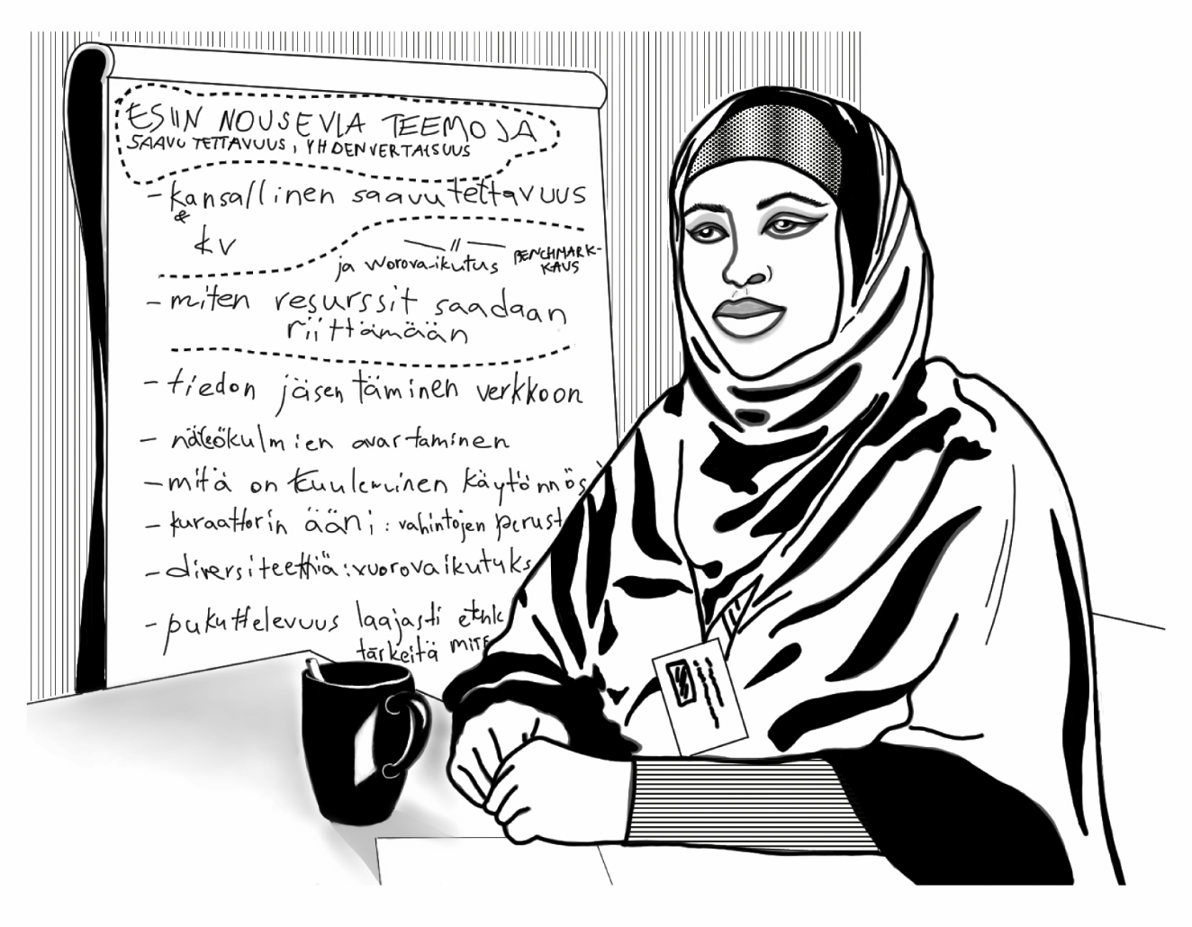

# 1 Strategic work and personnel

Accessibility, diversity, equality/equity and non-discrimination are among the important values of our museum. Our whole personnel understand these concepts and are committed to developing and, if need be, changing their practices to pursue equality.

* Achieved well.
* Achieved moderately well.
* Not achieved.

The goal is to fix:

By date:

Accessibility, diversity and equality as well as the principles of sustainable development are among the primary starting points of our planning and they have been entered in the strategies, visions, action plans, goals and other guidelines and budgets of our museum.

* Achieved well.
* Achieved moderately well.
* Not achieved.

The goal is to fix:

By date:

As part of the planning, we reserve resources, such as time and money, for the development of accessibility and paying attention to diversity. See also Chapter 2 Budgeting and procurements.

* Achieved well.
* Achieved moderately well.
* Not achieved.

The goal is to fix:

By date:

We have created at our museum decision making structures where our entire personnel have the chance to make a direct impact on the different levels of planning. For example, which matters should be prioritized in the various budgets of an organization.

* Achieved well.
* Achieved moderately well.
* Not achieved.

The goal is to fix:

By date:

We have prepared at our museum an equity/equality, accessibility and/or diversity plan, which names the goals, measures, schedules and responsible persons in these areas. We follow up on the achievement of the plan annually as a part of our budgetary preparations.

* Achieved well.
* Achieved moderately well.
* Not achieved.

The goal is to fix:

By date:

We aim to make our museum a discrimination-free and safer space for everyone.

* We have created principles for a safer space (see glossary).
* We are committed to the [Discrimination Free Zone (Syrjinnästä vapaa alue) campaign](https://yhdenvertaisuus.fi/en/joining-the-campaign).
* We are using the Yhdenvertaista palvelua kaikille (Equal Services for All) label (see [www.yhdenvertaistapalvelua.fi](http://www.yhdenvertaistapalvelua.fi)). (In Finnish.)
* Achieved well.
* Achieved moderately well.
* Not achieved.

The goal is to fix:

By date:

Competence in the areas of accessibility, diversity and equality are seen as assets in our recruitment practices.

* Achieved well.
* Achieved moderately well.
* Not achieved.

The goal is to fix:

By date:

We expect our personnel to commit to the development of cultural sensitivity and diversity skills.

* Achieved well.
* Achieved moderately well.
* Not achieved.

The goal is to fix:

By date:

We organize trainings related to accessibility and diversity for our personnel.

* Achieved well.
* Achieved moderately well.
* Not achieved.

The goal is to fix:

By date:

The perspectives of accessibility, diversity and equality are introduced in the training of new employees. The aim is that the employee will understand these concepts generally and become familiar with our museum’s own practices and solutions. This checklist can be used to support the training.

* Achieved well.
* Achieved moderately well.
* Not achieved.

The goal is to fix:

By date:

This accessibility and diversity checklist has been adapted to fit our museum as a regular tool for the personnel to use in, for example, exhibition planning.

* Achieved well.
* Achieved moderately well.
* Not achieved.

The goal is to fix:

By date:

We actively recruit personnel with diverse characteristics and backgrounds and adapt our requirements regarding language skills, educational background or prior experience so that our personnel reflect the demographics of the surrounding society.

* Achieved well.
* Achieved moderately well.
* Not achieved.

The goal is to fix:

By date:

Every member of our personnel has equal opportunities to develop and advance in their career regardless of their personal traits (for example, gender or belonging in a minority).

* Achieved well.
* Achieved moderately well.
* Not achieved.

The goal is to fix:

By date:

Every member of the personnel feels good at work. Special attention is paid to the wellbeing of those who are members of minorities.

* Achieved well.
* Achieved moderately well.
* Not achieved.

The goal is to fix:

By date:

Our museum offers different ways for giving feedback to the personnel, the audiences and our partners, also anonymously. For example, it would be good to carry out an anonymous e-survey at least once a year.

* Achieved well.
* Achieved moderately well.
* Not achieved.

The goal is to fix:

By date:

We cooperate in our strategic work as well as in the planning, implementation and assessment of our operations with experts representing different population groups, such as cultural and linguistic minorities, people with disabilities and members of sexual and gender minorities.

* Cooperation and interaction with different population groups are a part of the job description for at least a part of the personnel.
* We reserve time for the cooperation.
* We reserve money for the cooperation. We reserve money in the budgets for, for example, fees for experts by experience.
* Achieved well.
* Achieved moderately well.
* Not achieved.

The goal is to fix:

By date:

Notes, ideas, measures:

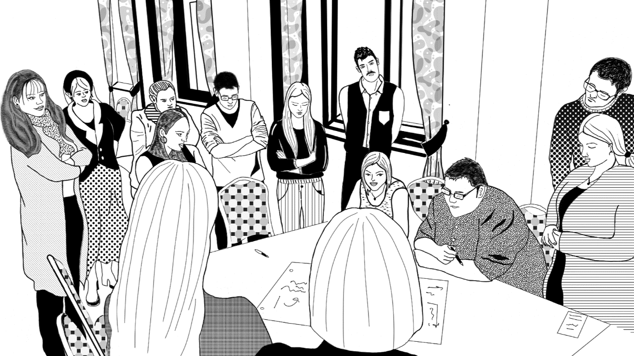

# 2 Budgeting and procurements

## 2.1 Budgeting

Development work on accessibility is included in our budgets.

* Achieved well.
* Achieved moderately well.
* Not achieved.

The goal is to fix:

By date:

Money is reserved in the budgets of our projects for costs connected to accessibility.

* Achieved well.
* Achieved moderately well.
* Not achieved.

The goal is to fix:

By date:

To enable participation for our staff and customers our budget is prepared for

* alteration work on the built environment
* purchases of, for example, assistive devices.
* Achieved well.
* Achieved moderately well.
* Not achieved.

The goal is to fix:

By date:

We reserve money in our budgets for buying expert services and for fees for experts by experience to support us with accessibility, diversity, and equality/equity issues.

* Achieved well.
* Achieved moderately well.
* Not achieved.

The goal is to fix:

By date:

We reserve money in our budgets to ensure that the staff can get training and acquire more information on accessibility, diversity, and equality/equity issues.

* Achieved well.
* Achieved moderately well.
* Not achieved.

The goal is to fix:

By date:

We reserve money in our budgets for interpretation services on our guided tours and at our seminars, cooperation meetings and events. The services may be sign language interpreting, Speech-to-Text interpreting and/or audio description.

* Achieved well.
* Achieved moderately well.
* Not achieved.

The goal is to fix:

By date:

## 2.2 Procurements and outsourced services

We pay attention to accessibility in all our procurements.

* Achieved well.
* Achieved moderately well.
* Not achieved.

The goal is to fix:

By date:

When we purchase services and products, we ask for bids from ethically sound service providers that represent diversity in a variety of ways. Diversity can be represented by, for example, organizations and businesses owned by and employing disabled people and/or people who belong to linguistic and cultural minorities.

* Achieved well.
* Achieved moderately well.
* Not achieved.

The goal is to fix:

By date:

Diversity is emphasized in the selection of service providers. In, for example, situations where the candidates seem equally good, a service provider can be favoured on the basis of personnel diversity.

* Achieved well.
* Achieved moderately well.
* Not achieved.

The goal is to fix:

By date:

## 2.3 ICT purchases, such as websites and mobile applications

We enter accessibility requirements in our calls for bids concerning digital products and services and websites. NOTE! The Finnish Act on the Provision of Digital Services states, among other things, that public museums and museums that receive more than 50 % of their funding from a public source must realize their web services in accordance with certain accessibility requirements. It is good to follow the accessibility requirements also at museums to which the law doesn’t apply. Further information: [www.saavutettavuusvaatimukset.fi](https://www.saavutettavuusvaatimukset.fi/). (In Finnish)

* In our calls for bids we set the requirement that the product/service/website meets with the standards A and AA of the [Web Content Accessibility Guidelines 2.1](https://www.w3.org/Translations/WCAG21-fi) (WCAG 2.1).
* In our calls for bids we set the requirement that a product/service/website meets with other accessibility standards such as, for example, the criteria for easy-to-use web services of the Papunet web service [Papunetin helppokäyttöisen verkkopalvelun kriteerit.](http://papunet.net/saavutettavuus/helppokayttoiset-verkkosivut) In Finnish. This is because the WCAG 2.1 do not cover all the aspects of accessibility but are focused on technical properties.
* Achieved well.
* Achieved moderately well.
* Not achieved.

The goal is to fix:

By date:

When choosing service providers for digital services we check that they are competent in matters of accessibility.

* Achieved well.
* Achieved moderately well.
* Not achieved.

The goal is to fix:

By date:

When choosing graphic designers, we check that the service provider is familiar with the principles of accessible graphic design.

* Achieved well.
* Achieved moderately well.
* Not achieved.

The goal is to fix:

By date:

When choosing a web service, website, or a web survey from a ready system as a platform, we have checked that:

* The platform meets with the A and AA standards of [WCAG 2.1](https://www.w3.org/Translations/WCAG21-fi/) (see Glossary).
* The platform meets with the Papunet criteria for easy-to-use web services ([Papunetin helppokäyttöisen verkkopalvelun kriteerit](http://papunet.net/saavutettavuus/helppokayttoiset-verkkosivut) (In Finnish)).
* Achieved well.
* Achieved moderately well.
* Not achieved.

The goal is to fix:

By date:

In our procurement processes we reserve time for ensuring the accessibility by means of

* effective realization
* expert assessments
* testing (applying, for example the method of testing where the testers include people with different kinds of functional disabilities. For concrete instructions for how to organize the testing, see, for example, the Finnish [Accessibility Guidelines for Public Libraries (PDF),](https://www.kulttuuriakaikille.fi/doc/guides/guidelines-for-accessible-libraries.pdf) Chapter 9.3.2 Usability testing.
* Achieved well.
* Achieved moderately well.
* Not achieved.

The goal is to fix:

By date:

We have commissioned an expert assessment of the accessibility and usability of the products/services/website.

* Achieved well.
* Achieved moderately well.
* Not achieved.

The goal is to fix:

By date:

We have tested the products/services/website we use in terms of easiness of use and accessibility (applying, for example, user testing as the method).

* Achieved well.
* Achieved moderately well.
* Not achieved.

The goal is to fix:

By date:

We have had the products/services/website assessed by an outside expert in terms of easiness of use and from the viewpoint of people who need easy language.

* Achieved well.
* Achieved moderately well.
* Not achieved.

The goal is to fix:

By date:

Notes, ideas, measures:

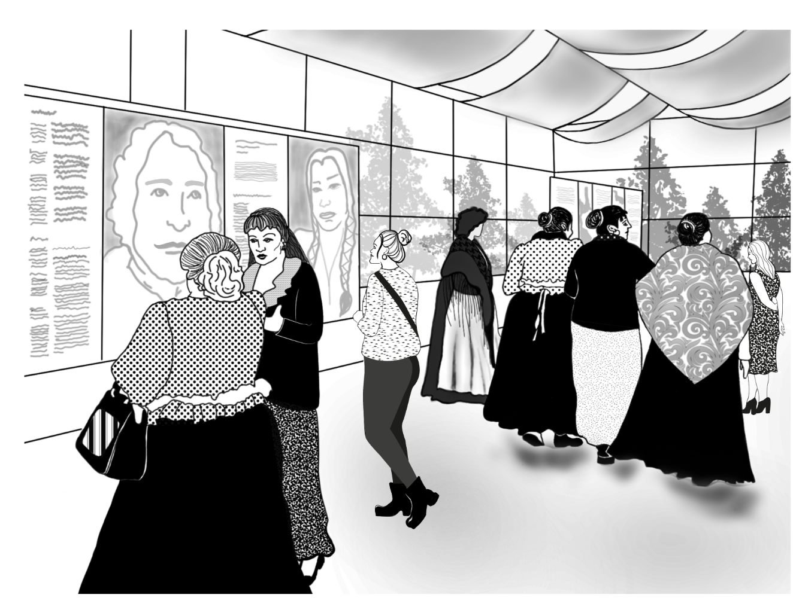

# 3 Exhibition contents, collections and archives

We strive towards equality and equity in our collection policy and in the contents of our exhibitions and materials:

* Diversity is represented among the creators and in the contents.
* The grounds for the selections are transparent.
* The processes are interactive and open.
* Achieved well.
* Achieved moderately well.
* Not achieved.

The goal is to fix:

By date:

We create in our exhibition activities and other contents a dialogical connection between the topics that we address and the changing society.

* Achieved well.
* Achieved moderately well.
* Not achieved.

The goal is to fix:

By date:

We avoid reinforcing prejudices and stereotypes connected to minorities or gender in our exhibition and other material.

* Achieved well.
* Achieved moderately well.
* Not achieved.

The goal is to fix:

By date:

We recognize that the expertise our museum needs can be found in different directions, different social strata and from outside the museum. At our museum we make use of expertise that represents diversity as well as information produced by minorities.

* Achieved well.
* Achieved moderately well.
* Not achieved.

The goal is to fix:

By date:

In our acquisitions and decisions on what we select into our collections we give attention to materials and matters relating to minorities. We make sure that minorities provide background information on the materials relating to them.

* Achieved well.
* Achieved moderately well.
* Not achieved.

The goal is to fix:

By date:

We pay attention to the perspectives of diversity and equity/equality also in contemporary documentation. We deposit in our collections material/art relating to the life of minorities.

* Achieved well.
* Achieved moderately well.
* Not achieved.

The goal is to fix:

By date:

We pay attention to diversity in our choice of wording in indexing and in how we describe the contexts.

* Achieved well.
* Achieved moderately well.
* Not achieved.

The goal is to fix:

By date:

We recognize that our culture-bound ties exist and reflect on our work at the museum. Our experts represent diversity, we highlight and deal with different traditions and make room for the questioning of norms.

* Achieved well.
* Achieved moderately well.
* Not achieved.

The goal is to fix:

By date:

Notes, ideas, measures:

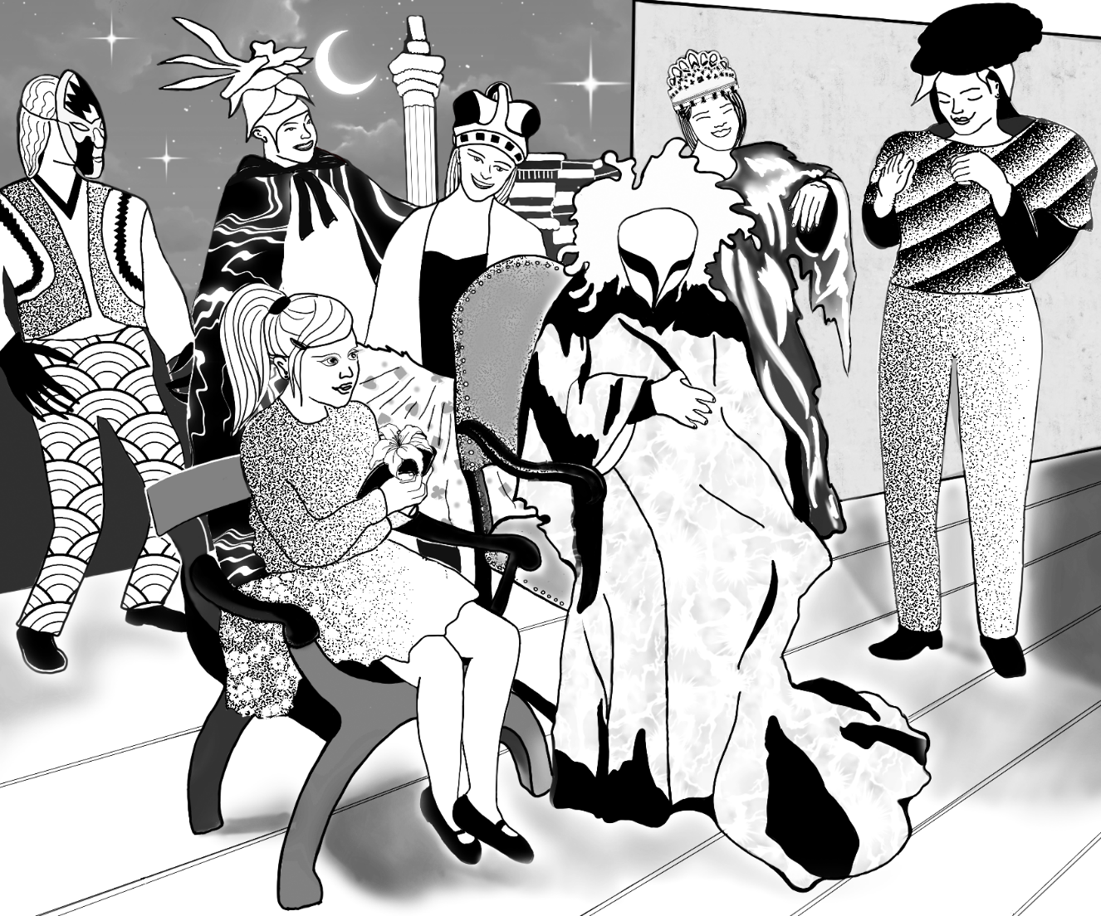

# 4 Public programming and audience engagement

The ways we reach out to our audience through, for example, exhibitions, performances, events, happenings and our digital supply as well as the contents of our learning materials and other materials reflect the diversity of the society and its people.

* Achieved well.
* Achieved moderately well.
* Not achieved.

The goal is to fix:

By date:

Our public programming and audience engagement reaches a wide range of participants who represent diversity.

* Achieved well.
* Achieved moderately well.
* Not achieved.

The goal is to fix:

By date:

We offer guided tours, workshops, openings, lectures, artist meetings and other events where accessibility is taken into consideration.

* Achieved well.
* Achieved moderately well.
* Not achieved.

The goal is to fix:

By date:

Our public programming in digital form is realized accessibly. See also Chapter 7 Communications and Chapter 2.3. ICT purchases on the accessibility of web environments.

* Achieved well.
* Achieved moderately well.
* Not achieved.

The goal is to fix:

By date:

Our services are as accessible as possible and they can be customized if need be.

* Achieved well.
* Achieved moderately well.
* Not achieved.

The goal is to fix:

By date:

Our audience engagement personnel have received training on accessibility and paying attention to diversity.

* Achieved well.
* Achieved moderately well.
* Not achieved.

The goal is to fix:

By date:

We engage audiences in cooperation with different actors in society, including minorities. We invite a diverse range of people and organizations to take part in the planning, implementation and assessment of our public programming.

Our museum plans and reaches out to audiences also in cooperation with actors in the social welfare sector and clients of Social Services.

* Achieved well.
* Achieved moderately well.
* Not achieved.

The goal is to fix:

By date:

We organize outreach programmes also elsewhere than on the museum premises.

* Our museum reaches out to, for example, schools and different institutions, like care institutions, nursing homes, housing services, reception centres and prisons.
* Achieved well.
* Achieved moderately well.
* Not achieved.

The goal is to fix:

By date:

We offer activities at a variety of times; during the days, in the evenings, on workdays and on weekends.

* Achieved well.
* Achieved moderately well.
* Not achieved.

The goal is to fix:

By date:

## 4.1 Guided tours and workshops

We offer guided tours in several languages as well as guided tours with audio description, in sign language or interpreted into sign language and guided tours in Easy Language.

* Achieved well.
* Achieved moderately well.
* Not achieved.

The goal is to fix:

By date:

On our guided tours assistive devices such as portable chairs, walkers, wheelchairs, prams, walking canes, magnifying glasses, protective gloves (for touching the objects/artworks), flashlights and hearing aids are available to the customers.

* Achieved well.
* Achieved moderately well.
* Not achieved.

The goal is to fix:

By date:

Our museum offers audio guides, which can be listened to either with the museum’s own equipment or with the clients’ own devices through the web.

* The audio guides include audio description, meaning that the museum objects or artworks are verbally described.
* There is also an audio guide available in Easy Language.
* Listening to the audio guides is sufficiently easy. For example, people with functional disabilities of various kind can easily find the right switches.
* Achieved well.
* Achieved moderately well.
* Not achieved.

The goal is to fix:

By date:

We customize our workshop activities to be as accessible as possible, according to the participants’ needs. For example, the duration of a workshop can be adjusted to be more appropriate, attention can be paid to the participants’ possible need for assistance (more guides or general assistants) and different tools and techniques can be applied when needed.

* Achieved well.
* Achieved moderately well.
* Not achieved.

The goal is to fix:

By date:

In our workshops we provide for different learning styles.

* Achieved well.
* Achieved moderately well.
* Not achieved.

The goal is to fix:

By date:

## 4.2 Events

Different interpretation services are available at our events, such as sign language interpretation and Speech-to-Text interpretation.

* Achieved well.
* Achieved moderately well.
* Not achieved.

The goal is to fix:

By date:

Our events are held in accessible spaces. If a museum has both accessible and hard-to-access spaces we choose the accessible space for the event.

* Achieved well.
* Achieved moderately well.
* Not achieved.

The goal is to fix:

By date:

There is a sound transfer system, such as a hearing induction loop system, available at our events.

* Achieved well.
* Achieved moderately well.
* Not achieved.

The goal is to fix:

By date:

The events at our museum are free of charge, moderately priced or included in the admission fee.

* Achieved well.
* Achieved moderately well.
* Not achieved.

The goal is to fix:

By date:

Our museum applies principles for a safer space (see glossary) and we highlight them also at our events.

* Achieved well.
* Achieved moderately well.
* Not achieved.

The goal is to fix:

By date:

Our museum is committed to the [Discrimination Free Zone](https://yhdenvertaisuus.fi/en/joining-the-campaign) (Syrjinnästä vapaa alue) campaign in Finland and Discrimination Free Zone signs are visibly placed at our events.

* Achieved well.
* Achieved moderately well.
* Not achieved.

The goal is to fix:

By date:

We go through the principles for a safer space and/or Discrimination Free Zone also with the external organizers of events.

* Achieved well.
* Achieved moderately well.
* Not achieved.

The goal is to fix:

By date:

Our communications about the event include information about accessibility at the event.

* Achieved well.
* Achieved moderately well.
* Not achieved.

The goal is to fix:

By date:

We are ready, if need be, to organize general assistants for the events who can, for example, open doors or help people get in and out of their outdoor clothes or offer help at workshops, and thereby make it possible for people who need assistance to participate. The general assistants can be trained volunteers or members of the museum staff.

* Achieved well.
* Achieved moderately well.
* Not achieved.

The goal is to fix:

By date:

Notes, ideas, measures:

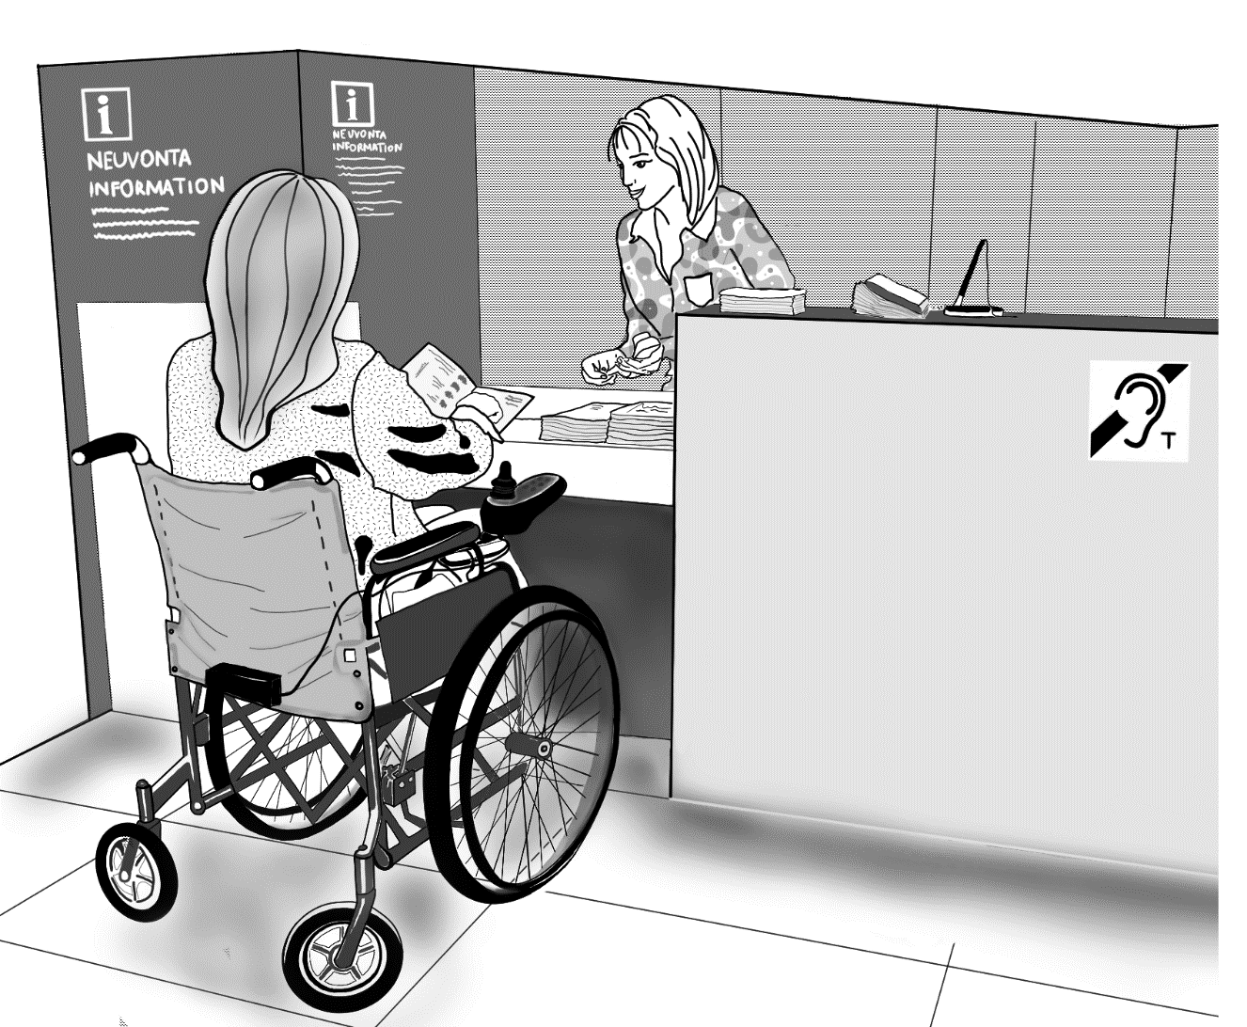

# 5 Customer service

## 5.1 Training and introduction for the customer service staff

All our employees are instructed at the start of their work to encounter all customers with respect and appreciation regardless of their different characteristics connected to, for example, disability, gender and sexual diversity or way of dressing.

* Achieved well.
* Achieved moderately well.
* Not achieved.

The goal is to fix:

By date:

Our customer service staff are familiar with the accessibility solutions on our premises and the services we provide linked to accessibility and diversity.

* Achieved well.
* Achieved moderately well.
* Not achieved.

The goal is to fix:

By date:

Our customer service staff have received training to develop their interaction skills.

* Achieved well.
* Achieved moderately well.
* Not achieved.

The goal is to fix:

By date:

Our customer service staff and other personnel have received instructions on how to interfere with inappropriate behaviour.

* Achieved well.
* Achieved moderately well.
* Not achieved.

The goal is to fix:

By date:

The staff recognize the situations where a customer or a member of the staff is treated inappropriately and interfere in them.

* Achieved well.
* Achieved moderately well.
* Not achieved.

The goal is to fix:

By date:

Our entire staff have received an introduction to how the assistive devices loaned out at the customer service desk are used.

* Achieved well.
* Achieved moderately well.
* Not achieved.

The goal is to fix:

By date:

If there is a hearing induction loop system, the staff have received training in how to use it.

* Achieved well.
* Achieved moderately well.
* Not achieved.

The goal is to fix:

By date:

## 5.2 Language and communications

We serve our customers in different languages. The language options are communicated to the customers.

* Achieved well.
* Achieved moderately well.
* Not achieved.

The goal is to fix:

By date:

Our customer service staff know the basics of sign language.

* Achieved well.
* Achieved moderately well.
* Not achieved.

The goal is to fix:

By date:

Our customer service staff communicate with the customer directly, even if the customer is accompanied with a personal assistant or interpreter.

* Achieved well.
* Achieved moderately well.
* Not achieved.

The goal is to fix:

By date:

Our customer service staff are prepared to use different ways of communication, such as writing things on paper, using easy language or communicating with pictures and symbols.

* Achieved well.
* Achieved moderately well.
* Not achieved.

The goal is to fix:

By date:

## 5.3 Service

The customers of our museum can receive personal customer service in many different ways, such as face to face, on the phone and via email or chat.

* Achieved well.
* Achieved moderately well.
* Not achieved.

The goal is to fix:

By date:

Our museum can be flexible with its opening hours.

* Achieved well.
* Achieved moderately well.
* Not achieved.

The goal is to fix:

By date:

It is possible to organize visits to the museum at times when there are no other visitors present.

* Achieved well.
* Achieved moderately well.
* Not achieved.

The goal is to fix:

By date:

Our museum is a part of the local Culture Pilot/Culture Companion network. The social threshold to visiting a museum can be lowered by the possibility of coming to the museum together with a voluntary companion.

* Achieved well.
* Achieved moderately well.
* Not achieved.

The goal is to fix:

By date:

The service at our cafeteria and restaurant takes different diets and allergies into account. The menus are marked clearly with information regarding special dietary requirements.

* Achieved well.
* Achieved moderately well.
* Not achieved.

The goal is to fix:

By date:

The customer can bring along an assistance dog or leave it to a safe designated place to wait.

* Achieved well.
* Achieved moderately well.
* Not achieved.

The goal is to fix:

By date:

It is possible for our customers to also retreat into a peaceful, less stimulating place if needed.

* Achieved well.
* Achieved moderately well.
* Not achieved.

The goal is to fix:

By date:

## 5.4 Assistance

Our customer service staff are ready to assist customers with disabilities.

* Achieved well.
* Achieved moderately well.
* Not achieved.

The goal is to fix:

By date:

Our museum is ready to call in general assistants who can, for example, open doors, help the customer get in or out of outdoor clothes or offer help at workshops and thereby make it possible for people who need assistance to participate. The general assistants can be trained volunteers or members of the museum staff.

* Achieved well.
* Achieved moderately well.
* Not achieved.

The goal is to fix:

By date:

## 5.5 Assistive devices and accessibility solutions

The customer service desk at our museum has and loans out assistive devices, such as walkers, wheelchairs, portable chairs, prams, magnifying glasses and flashlights. For guided tours we also loan out protective gloves (for touching the objects/artworks) to use with a guide’s assistance, as well as hearing aids.

* Achieved well.
* Achieved moderately well.
* Not achieved.

The goal is to fix:

By date:

The services that enhance accessibility, such as loaning of assistive devices, are actively promoted and offered to the customers.

* Achieved well.
* Achieved moderately well.
* Not achieved.

The goal is to fix:

By date:

The visitors are informed of the services, such as the loaning of assistive devices, at the customer service desk also in the form of pictures and/or symbols.

* Achieved well.
* Achieved moderately well.
* Not achieved.

The goal is to fix:

By date:

Hearing induction loop and other audio transmission systems

* There is an induction loop at the customer service desk of our museum, or there is some other equivalent sound transfer system, which the personnel know how to use.
* We have signs with symbols to inform our visitors of the possibility to use an induction loop or other sound transfer system wherever the equipment can be used. The area of use of the induction loop is also marked on the signs.
* We regularly service the induction loop equipment or other equivalent sound transfer system.
* Achieved well.
* Achieved moderately well.
* Not achieved.

The goal is to fix:

By date:

There is a tactile map and/or scale model of the museum building, grounds and premises and the surrounding streets, to especially serve customers with visual impairments.

* Achieved well.
* Achieved moderately well.
* Not achieved.

The goal is to fix:

By date:

There is a verbal map (narrated route map) available at our website, to serve especially our customers with visual impairments. The staff inform the customers about the option to use a verbal map. The map describes the space and routes verbally and so helps the customer to find the essential services.

* Achieved well.
* Achieved moderately well.
* Not achieved.

The goal is to fix:

By date:

Our customer service desk offers visitors museum guide maps to take along.

* Achieved well.
* Achieved moderately well.
* Not achieved.

The goal is to fix:

By date:

## 5.6 Exhibition supervision

The exhibition floor supervisors act in a polite and discreet way and have good interaction skills.

* The exhibition floor supervisors know how to give room for the exhibition experience.
* The exhibition floor supervisors give advice when needed and ask the customers if they need help.
* Achieved well.
* Achieved moderately well.
* Not achieved.

The goal is to fix:

By date:

Notes, ideas, measures:

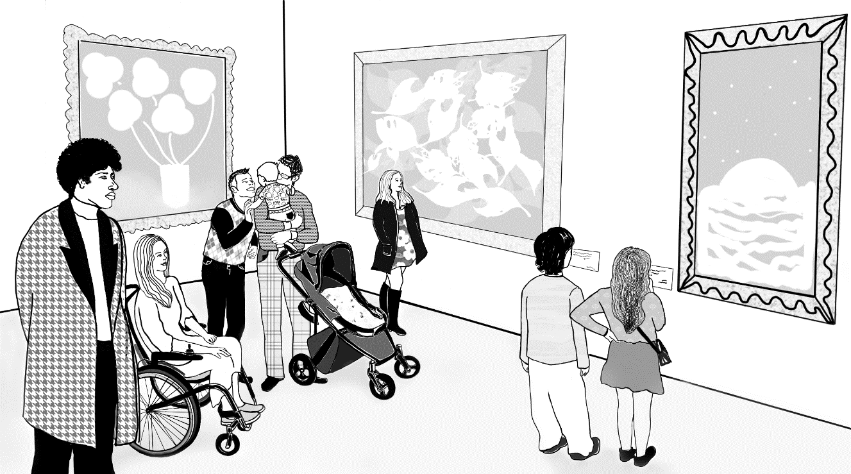

# 6 Pricing

The assistants and interpreters of people with disabilities receive free tickets to the museum and the events. We do not ask for proof of the need for an assistant or interpreter but trust in the customer’s own notification. See [Suomen Museoliiton suositus: Museovieraiden avustajille vapaa sisäänpääsy](https://museoliitto.fi/jasentiedotteet.php?aid=12543). (Recommendation of the Finnish Museums Association: Free admission to assistants to museum visitors. In Finnish).

* Achieved well.
* Achieved moderately well.
* Not achieved.

The goal is to fix:

By date:

The support persons for persons in mental health rehabilitation or persons with memory loss get free tickets to the museum and events. We do not ask for proof of the need for a support person but trust in the customer’s own notification.

* Achieved well.
* Achieved moderately well.
* Not achieved.

The goal is to fix:

By date:

It is communicated at our museum’s website that the assistants, interpreters and/or support persons get free tickets to our museum and events.

* Achieved well.
* Achieved moderately well.
* Not achieved.

The goal is to fix:

By date:

Our museum belongs in the local Culture Pilot/Culture Companion network. Customers can visit our museum and its events together with a voluntary Culture Pilot at a discounted rate. We offer the companions free admission to our museum or events.

* Achieved well.
* Achieved moderately well.
* Not achieved.

The goal is to fix:

By date:

The tickets to our museum and events are reasonably priced.

* Achieved well.
* Achieved moderately well.
* Not achieved.

The goal is to fix:

By date:

The prices of admission to our museum and events are graded (discounts for students, unemployed persons, pensioners).

* Achieved well.
* Achieved moderately well.
* Not achieved.

The goal is to fix:

By date:

We give discounts to groups, also small groups, on admission fees to the museum and events.

* Achieved well.
* Achieved moderately well.
* Not achieved.

The goal is to fix:

By date:

There is a family ticket available to families, for example, two adults and their children. (NOTE: there must be no restrictions with regard to the gender of the parents or the number of children.)

* Achieved well.
* Achieved moderately well.
* Not achieved.

The goal is to fix:

By date:

There regularly are times, events and programme contents at our museum with free admission for all.

* Achieved well.
* Achieved moderately well.
* Not achieved.

The goal is to fix:

By date:

Our museum has targeted free services:

* It is possible for persons and families of low income to gain free admission and free tickets to our events with, for example, the Kaikukortti card or some other similar system: [kaikukortti.fi/en](http://www.kaikukortti.fi/en).
* We offer through, for example, Social Services free tickets to be distributed to people of low income.
* We offer unsold tickets to events to, for example, clients of Social Services.
* Achieved well.
* Achieved moderately well.
* Not achieved.

The goal is to fix:

By date:

Our museum offers the possibility of free checkroom services.

* Achieved well.
* Achieved moderately well.
* Not achieved.

The goal is to fix:

By date:

Persons and families who are financially hard pressed are taken into account in the pricing of our extra services, such as the products sold at the restaurants, cafes or shops.

* Achieved well.
* Achieved moderately well.
* Not achieved.

The goal is to fix:

By date:

Our museum offers an area where visitors can bring their own food and refreshments.

* Achieved well.
* Achieved moderately well.
* Not achieved.

The goal is to fix:

By date:

The is no fee for using the assistive devices offered by the museum. For example, visitors with visual impairments are not charged for using an audio guide, since the listenable information substitutes for the wall texts.

* Achieved well.
* Achieved moderately well.
* Not achieved.

The goal is to fix:

By date:

Notes, ideas, measures:

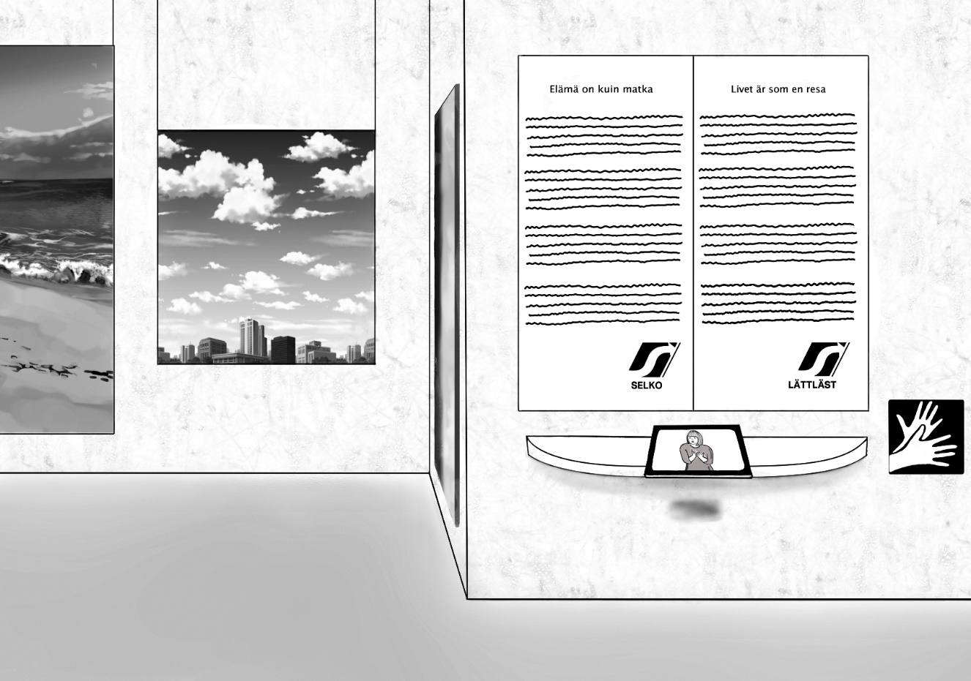

# 7 Communications

We use a diverse range of communication channels, such as websites, social media and printed brochures.

* Achieved well.
* Achieved moderately well.
* Not achieved.

The goal is to fix:

By date:

We focus communications directly to different minority groups through, for example, organizations for people with disabilities or members of cultural minorities and other actors that represent diversity.

* Achieved well.
* Achieved moderately well.
* Not achieved.

The goal is to fix:

By date:

We communicate directly to different target groups about our services that especially pay attention to accessibility and diversity.

* Achieved well.
* Achieved moderately well.
* Not achieved.

The goal is to fix:

By date:

We include in our general communications information about our services that especially pay attention to accessibility and diversity.

* Achieved well.
* Achieved moderately well.
* Not achieved.

The goal is to fix:

By date:

## 7.1 Language options and Easy Language

We use also other languages than Finnish and Swedish in our communications.

* Achieved well.
* Achieved moderately well.
* Not achieved.

The goal is to fix:

By date:

We use different languages in our announcements.

* Achieved well.
* Achieved moderately well.
* Not achieved.

The goal is to fix:

By date:

We use clear and easy-to-understand language in our communications.

* Achieved well.
* Achieved moderately well.
* Not achieved.

The goal is to fix:

By date:

We use easy language in our communications.

* Achieved well.
* Achieved moderately well.
* Not achieved.

The goal is to fix:

By date:

We use sign language in our communications.

* Achieved well.
* Achieved moderately well.
* Not achieved.

The goal is to fix:

By date:

## 7.2 Graphic design

The visual appearance of our communications materials is clear.

* We use a clear font type and a large enough font size.
* We choose the colours so that the contrast between the text and background is strong enough. The contrast rate can be checked using, for example, the [WebAIM Contrast checker](https://webaim.org/resources/contrastchecker/).
* We avoid placing text over an image or a patterned background.
* Achieved well.
* Achieved moderately well.
* Not achieved.

The goal is to fix:

By date:

We use in our communications images such as photos and drawings to support understanding.

* Achieved well.
* Achieved moderately well.
* Not achieved.

The goal is to fix:

By date:

If our museum uses graphic design guidelines that are contradictory to accessibility guidelines, we update them appropriately. If the guidelines are issued externally, by for example, the municipality, we try to influence the provider to revise them.

* Achieved well.
* Achieved moderately well.
* Not achieved.

The goal is to fix:

By date:

## 7.3 Accessibility information and other central information

The most important information, such as the opening hours, accessibility information, address, admission prices and personnel contact information are easy to find and understand.

* Achieved well.
* Achieved moderately well.
* Not achieved.

The goal is to fix:

By date:

We provide information on the accessibility of our museum with symbols and texts at our website and in our brochures. Further information: [Entä saavutettavuus? Ohje kulttuurikohteen saavutettavuudesta viestimiseen](http://www.kulttuuriakaikille.fi/saavutettavuus_tietopaketit_ja_oppaat_viestinta). (In Finnish)

* Achieved well.
* Achieved moderately well.
* Not achieved.

The goal is to fix:

By date:

We provide information at our website and in our brochures about possible accessibility problems at the museum.

* Achieved well.
* Achieved moderately well.
* Not achieved.

The goal is to fix:

By date:

We name at our website and in our brochures and other communications material the persons who can give further information on the accessibility of the museum. We provide their contact details in the same context.

* Achieved well.
* Achieved moderately well.
* Not achieved.

The goal is to fix:

By date:

We provide information on the accessibility of our museum and events also in our social media channels. We include the accessibility information in, for example, our Instagram posts and Facebook events pages.

* Achieved well.
* Achieved moderately well.
* Not achieved.

The goal is to fix:

By date:

If there are high sound levels, flashing lights, smoke or strong odours at our exhibitions or events, it is notified at our website, in our brochures and on site.

* Achieved well.
* Achieved moderately well.
* Not achieved.

The goal is to fix:

By date:

We have prepared a Social Story of our museum (a type of visual script of a museum visit, see Glossary).

* The Social Story is available at our website.
* We send the Social Story to groups in advance.
* Achieved well.
* Achieved moderately well.
* Not achieved.

The goal is to fix:

By date:

We provide information in our communications on the typical hours when it is quiet or crowded at the museum.

* Achieved well.
* Achieved moderately well.
* Not achieved.

The goal is to fix:

By date:

## 7.4 Information for different senses

Information is also available in Braille when needed.

* Achieved well.
* Achieved moderately well.
* Not achieved.

The goal is to fix:

By date:

When announcements are made we provide the contents also in text form on screens or on paper.

* Achieved well.
* Achieved moderately well.
* Not achieved.

The goal is to fix:

By date:

Our website includes a verbal map (narrated route map) to especially serve our customers with visual impairments. A verbal map describes the space and routes verbally and can thus help customers to find the essential services.

* Achieved well.
* Achieved moderately well.
* Not achieved.

The goal is to fix:

By date:

## 7.5 Diversity and avoiding stereotypes

Diversity, in terms of, for example, gender, sexuality, disabilities, skin colour and religion, is reflected in our communications material and images.

* Achieved well.
* Achieved moderately well.
* Not achieved.

The goal is to fix:

By date:

We avoid in our communications anything that might strengthen stereotypes and normativity, such as the heteronormativity (see Glossary).

* Achieved well.
* Achieved moderately well.
* Not achieved.

The goal is to fix:

By date:

Our museum applies principles for a safer space (see Glossary), and we inform customers about them in our communications and on our premises.

* Achieved well.
* Achieved moderately well.
* Not achieved.

The goal is to fix:

By date:

We are committed to the [Discrimination Free Zone (Syrjinnästä vapaa alue) campaign in Finland](https://yhdenvertaisuus.fi/en/joining-the-campaign) and there are Discrimination Free Zone signs visibly placed at our museum.

* Achieved well.
* Achieved moderately well.
* Not achieved.

The goal is to fix:

By date:

## 7.6 Website

Commissioning a website: see Chapter 2.3 ICT purchases.

* Achieved well.
* Achieved moderately well.
* Not achieved.

The goal is to fix:

By date:

Our website is realized according to the Web Content Accessibility Guidelines [(WCAG) 2.1](https://www.w3.org/TR/2018/REC-WCAG21-20180605/).

* Achieved well.
* Achieved moderately well.
* Not achieved.

The goal is to fix:

By date:

### Assessment and testing

An external expert has assessed the accessibility of our website.

* Achieved well.
* Achieved moderately well.
* Not achieved.

The goal is to fix:

By date:

An external expert has assessed our website in terms of easiness of use and functionality from the viewpoint of people who need easy language.

* Achieved well.
* Achieved moderately well.
* Not achieved.

The goal is to fix:

By date:

A user testing has been performed on our website, and the test group included disabled people.

* Achieved well.
* Achieved moderately well.
* Not achieved.

The goal is to fix:

By date:

We regularly check the validity of the HTML code using, for example, the [W3C Markup Validation Service.](https://validator.w3.org)

* Achieved well.
* Achieved moderately well.
* Not achieved.

The goal is to fix:

By date:

Visitors to the website have the possibility to give feedback on the website in various ways, for example, through a web form and email or over the phone.

* Achieved well.
* Achieved moderately well.
* Not achieved.

The goal is to fix:

By date:

We regularly gather feedback from the users of the website.

* Achieved well.
* Achieved moderately well.
* Not achieved.

The goal is to fix:

By date:

### Clarity of the website

The website contains a reasonable amount of content and information.

* Achieved well.
* Achieved moderately well.
* Not achieved.

The goal is to fix:

By date:

The layout of our website is clear and the information is easy to find.

* The user can easily tell where the most essential content, the main content, of the website is.
* The navigation links (the main navigation and the sub navigation) can be clearly told apart from each other.
* The navigation links, the language menus and the other menus always remain in the same place as the user moves in different parts of the website.
* Achieved well.
* Achieved moderately well.
* Not achieved.

The goal is to fix:

By date:

The structure of our website is systematic and logical. The information is grouped into subject areas and it has a clear hierarchy.

* Achieved well.
* Achieved moderately well.
* Not achieved.

The goal is to fix:

By date:

The headings at our website have a clear hierarchy and they have been denoted as heading elements (H1 for Heading 1, H2 for Heading 2 etc.).

* Achieved well.
* Achieved moderately well.
* Not achieved.

The goal is to fix:

By date:

The headings and titles at our website are clear and describe the content.

* Achieved well.
* Achieved moderately well.
* Not achieved.

The goal is to fix:

By date:

When a user selects a certain section of our website the heading of that section is visually highlighted in the menu.

* Achieved well.
* Achieved moderately well.
* Not achieved.

The goal is to fix:

By date:

### Links and text alternatives for images

The links are informative, meaning that the link contains in itself enough information about where it leads (links like ”Read more” are not informative).

* Achieved well.
* Achieved moderately well.
* Not achieved.

The goal is to fix:

By date:

We do not use underlining anywhere else at the website except with the links.

* Achieved well.
* Achieved moderately well.
* Not achieved.

The goal is to fix:

By date:

If an image serves as a link we tell in its metadata where the link leads.

* Achieved well.
* Achieved moderately well.
* Not achieved.

The goal is to fix:

By date:

Short text alternatives have been added to the images (Text alternatives, see Glossary). Decorative images do not require text alternatives.

* Achieved well.
* Achieved moderately well.
* Not achieved.

The goal is to fix:

By date:

The contents of images that contain a lot of information (for example infographics, descriptors and graphs) are also available in text form.

* Achieved well.
* Achieved moderately well.
* Not achieved.

The goal is to fix:

By date:

### Website properties

Our website is compatible with assistive technologies, such as screen reader software.

* Achieved well.
* Achieved moderately well.
* Not achieved.

The goal is to fix:

By date:

Our website is operable with a wide range of terminal devices, including smartphones.

* Achieved well.
* Achieved moderately well.
* Not achieved.

The goal is to fix:

By date:

The design of our website is responsive. A responsive design adapts to the size of the screen in different terminal devices, such as desktop computers, tablets and smartphones.

* Achieved well.
* Achieved moderately well.
* Not achieved.

The goal is to fix:

By date:

The text at our website can be enlarged.

* Achieved well.
* Achieved moderately well.
* Not achieved.

The goal is to fix:

By date:

Our website includes a Listen function.

* Achieved well.
* Achieved moderately well.
* Not achieved.

The goal is to fix:

By date:

Our website includes a Search function.

* Achieved well.
* Achieved moderately well.
* Not achieved.

The goal is to fix:

By date:

Our website includes a site map.

* Achieved well.
* Achieved moderately well.
* Not achieved.

The goal is to fix:

By date:

Our website is easy to find with search engines.

* Achieved well.
* Achieved moderately well.
* Not achieved.

The goal is to fix:

By date:

Our website is easy to use with a keyboard, without a mouse.

* Achieved well.
* Achieved moderately well.
* Not achieved.

The goal is to fix:

By date:

The colours of our website can be inverted, meaning that the contents can be browsed as so-called negative text.

* Achieved well.
* Achieved moderately well.
* Not achieved.

The goal is to fix:

By date:

Neither our website nor any other element of our communications uses flashing contents, which could trigger seizures in some of the users.

* Achieved well.
* Achieved moderately well.
* Not achieved.

The goal is to fix:

By date:

We avoid autoplaying videos at our website. Motion disturbs reading.

* Achieved well.
* Achieved moderately well.
* Not achieved.

The goal is to fix:

By date:

We avoid auto-updating content (for example, autoplaying image carousels and news streaming) at our website. Image carousels are difficult to realize accessibly: the reading time is usually too short and the content might be impossible or illogical to navigate with a keyboard or a mobile device.

* Achieved well.
* Achieved moderately well.
* Not achieved.

The goal is to fix:

By date:

### Files, videos and forms at the website

The contents of all the PDF files at our website are also available in other formats (HTML, DOC, RTF). It is better to use PDF files only to present information that is meant to be printed out.

* Achieved well.
* Achieved moderately well.
* Not achieved.

The goal is to fix:

By date:

All the files at our website, such as the files in DOC and PDF format, have been realized in an accessible way. Guidelines for creating accessible files: [WebAIM: Document and media accessibility](https://webaim.org/articles/#richmedia).

* Achieved well.
* Achieved moderately well.
* Not achieved.

The goal is to fix:

By date:

All the videos at our website are captioned. The Finnish Act on the Provision of Digital Services requires that public organizations must have captions on their videos. Further information: [Saavutettavuusvaatimukset.fi: Videoiden ja äänilähetysten saavutettavuus](http://www.saavutettavuusvaatimukset.fi/lait-ja-standardit/videoiden-ja-aanilahetysten-saavutettavuus) (In Finnish). Information about captions in general: [WebAIM: Captions](https://webaim.org/techniques/captions/#captions).

* Achieved well.
* Achieved moderately well.
* Not achieved.

The goal is to fix:

By date:

The videos at our website have audio description.

* Achieved well.
* Achieved moderately well.
* Not achieved.

The goal is to fix:

By date:

The videos at our website have sign language interpretation.

* Achieved well.
* Achieved moderately well.
* Not achieved.

The goal is to fix:

By date:

Our website has videos in sign language.

* Achieved well.
* Achieved moderately well.
* Not achieved.

The goal is to fix:

By date:

The forms at our website are designed to be accessible. Further information: [WebAIM: Creating Accessible Forms](https://webaim.org/techniques/forms/).

* Achieved well.
* Achieved moderately well.
* Not achieved.

The goal is to fix:

By date:

## 7.7 Online newsletters and stores

Our online newsletters are accessible and easy to use.

* Achieved well.
* Achieved moderately well.
* Not achieved.

The goal is to fix:

By date:

Our possible online store has been realized according to the [Web Content Accessibility Guidelines (WCAG) 2.1](https://www.w3.org/TR/2018/REC-WCAG21-20180605) and it is easy to use.

* An external expert has performed an accessibility assessment of our online store.
* A user testing has been performed on our website, with testers including disabled people.
* Achieved well.
* Achieved moderately well.
* Not achieved.

The goal is to fix:

By date:

Notes, ideas, measures:

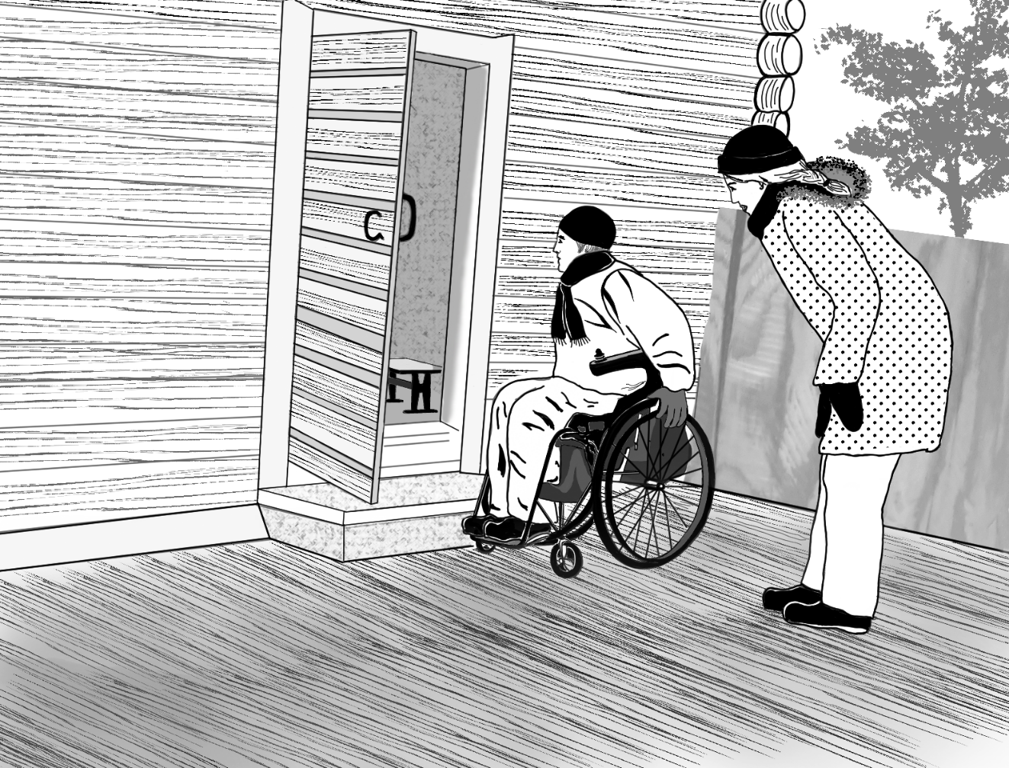

# 8 Museum area, spaces and facilities

## 8.1 Coming to the museum

One can come to our museum using different means of transportation, such as public transport, taxis, private cars and bicycles, or by foot.

* Achieved well.
* Achieved moderately well.
* Not achieved.

The goal is to fix:

By date:

There are free accessible parking places close to the accessible entrances, equipped with appropriate signs.

* Achieved well.
* Achieved moderately well.
* Not achieved.

The goal is to fix:

By date:

The main entrance is accessible.

* Achieved well.
* Achieved moderately well.
* Not achieved.

The goal is to fix:

By date:

The main entrance is not accessible but there are signs with wheelchair symbols pointing out the way to an accessible entrance.

* Achieved well.
* Achieved moderately well.
* Not achieved.

The goal is to fix:

By date:

## 8.2 Signs

The route to the museum entrance is clearly marked with signs.

* Achieved well.
* Achieved moderately well.
* Not achieved.

The goal is to fix:

By date:

In our museum it is easy for visitors to find what they are looking for. The signs are clear and located in places where they are easy to see. See also guidelines for exhibition texts (Chapter 8.6).

* Achieved well.
* Achieved moderately well.
* Not achieved.

The goal is to fix:

By date:

In our museum there is a tactile map and/or scale model of the museum building, museum grounds and premises and the surrounding streets, to especially serve customers with visual impairments.

* Achieved well.
* Achieved moderately well.
* Not achieved.

The goal is to fix:

By date:

## 8.3 Getting around on the museum premises

It is possible to move around in our museum without accessibility barriers (pertains to the areas and spaces connected to coming to the museum, all the customer and exhibition spaces, the exhibition structures and the staff premises):

* The doorways are at least 850 mm wide.
* The door handles, door release buttons, doorbells and door phones are located 850–1 100 mm from the ground.
* The pathways are wide enough and there is enough room to turn every 15 meters, at least 1 500 mm in diameter (turning a wheelchair around requires an unobstructed space of at least 1 500 mm).
* The surface materials of the pathways are hard, level and skidproof even when wet.
* The thresholds are no higher than 20 mm.
* The doors are light to open or open automatically.
* The maximum slope of the ramps is 8 %, and they have handrails and edge barriers on both sides.
* When the level difference is over 1 000 mm, there is a ramp, platform lift or stairlift alongside the stairs.
* Alongside the stairs there is an elevator with unobstructed access that complies with the minimum measurements (free width at least 1 100 mm and depth at least 1 400 mm).
* The service desks, such as ticket sales and the info desk, are designed so that the customers can access them either sitting or standing. This means that the counters are located at the heights of 1 200 mm and 750–800 mm and beneath the counters there is at least 670 mm of free vertical space for knees.
* Achieved well.
* Achieved moderately well.
* Not achieved.

The goal is to fix:

By date:

Our museum has accessible restrooms for the customers and the staff, which are equipped appropriately and which meet with the legal accessibility requirements. A wheelchair needs a free space of at least 1 500 mm to turn around. There has to be 800 mm of free space on both sides of the toilet seat. See [Invalidiliiton ohje Yleinen esteetön wc](https://www.invalidiliitto.fi/esteettomyys/julkinen-rakennus/yleinen-esteeton-wc) and [valtioneuvoston asetus rakennuksen esteettömyydestä](http://www.finlex.fi/fi/laki/alkup/2017/20170241). (In Finnish).

* Achieved well.
* Achieved moderately well.
* Not achieved.

The goal is to fix:

By date:

Our museum has gender-neutral restroom facilities for both the customers and the staff. A gender-neutral restroom takes gender diversity into consideration and also offers the possibility for persons with disabilities to be accompanied with an assistant of a different gender.

* Achieved well.
* Achieved moderately well.
* Not achieved.

The goal is to fix:

By date:

All the stairs and ramps have handrails.

* Achieved well.
* Achieved moderately well.
* Not achieved.

The goal is to fix:

By date:

Our museum has seats in all the museum spaces, some of which are sturdy chairs with a height of 500–550 mm equipped with backrests and armrests. The exhibition spaces have seats from which the exhibition can also be viewed sitting down.

* Achieved well.
* Achieved moderately well.
* Not achieved.

The goal is to fix:

By date:

All our museum spaces, including our shops, resting spaces and cafes, are furnished spaciously enough to serve customers who use assistive devices (free width of paths at least 900 mm).

* Achieved well.
* Achieved moderately well.
* Not achieved.

The goal is to fix:

By date:

## 8.4 The sensory environment

We pay attention in our exhibitions to different ways of using the senses and offer information and experiences in multisensory forms.

* Achieved well.
* Achieved moderately well.
* Not achieved.

The goal is to fix:

By date:

In our museum colour and contrast differences make it easier to perceive the spaces. For example, the colour contrast between the floor and walls is strong enough for them to be told easily apart.

* Achieved well.
* Achieved moderately well.
* Not achieved.

The goal is to fix:

By date:

The materials and colours of the furniture and surfaces have been chosen to ensure that, for example, the doors are easy to tell apart from the walls and the seats stand out clearly from their backgrounds.

* Achieved well.
* Achieved moderately well.
* Not achieved.

The goal is to fix:

By date:

Places with level differences, such as steps and bottoms and tops of staircases, are marked with stair warnings (tactile patterns and colour contrast).

* Achieved well.
* Achieved moderately well.
* Not achieved.

The goal is to fix:

By date:

The lighting is strong enough, even and glare-free in all our spaces.

* Achieved well.
* Achieved moderately well.
* Not achieved.

The goal is to fix:

By date:

The pathways and, for example, the readable signs and wall texts are clearly lit both indoors and outdoors.

* Achieved well.
* Achieved moderately well.
* Not achieved.

The goal is to fix:

By date:

Our museum has a pathway marked with direction-guiding floor markings with tactile surface material (guiding strip). The pathway has been tested to work for visitors with visual impairments. Raised lines indicate, for example, the intersections in the pathways.

* Achieved well.
* Achieved moderately well.
* Not achieved.

The goal is to fix:

By date:

The soundscape of our museum doesn’t consist background noise or echoes that would disturb hearing.

* Achieved well.
* Achieved moderately well.
* Not achieved.

The goal is to fix:

By date:

The videos, sound installations and other similar pieces in our exhibition spaces have adjustable volume. Visitors who are sensitive to sound may wish for a lower volume.

* Achieved well.
* Achieved moderately well.
* Not achieved.

The goal is to fix:

By date:

Our museum has a hearing induction loop or other sound transfer system.

* Achieved well.
* Achieved moderately well.
* Not achieved.

The goal is to fix:

By date:

We design the multisensory elements to be as accessible as possible. We offer easy-to-use alternatives for seeing, hearing and touching and avoid overburdening the senses with, for example, flashing lights, strong fragrancies or surprising sounds.

* Achieved well.
* Achieved moderately well.
* Not achieved.

The goal is to fix:

By date:

Our museum takes care of the air quality of the indoor spaces with effective ventilation and using, for example, fragrance-free detergents and fragrance-free hand soaps.

* Achieved well.
* Achieved moderately well.
* Not achieved.

The goal is to fix:

By date:

We instruct our customers and staff not to use strong perfumes or other fragrances in the museum.

* Achieved well.
* Achieved moderately well.
* Not achieved.

The goal is to fix:

By date:

## 8.5 Exhibition construction

We have instructions for the exhibition designers and builders for checking the accessibility criteria for getting around easily and seeing, hearing and understanding things easily.

* Achieved well.
* Achieved moderately well.
* Not achieved.

The goal is to fix:

By date:

Our exhibitions are designed so that customers who use assistive devices can also get close to the works and objects. There is free space around them and the pathways are 900–1 500 mm wide.

* Achieved well.
* Achieved moderately well.
* Not achieved.

The goal is to fix:

By date:

The works and objects are placed so that if they are intended to be viewed at close range the viewing height is 800–1 600 mm.

* Achieved well.
* Achieved moderately well.
* Not achieved.

The goal is to fix:

By date:

Individual exhibition objects stand out from their background through a strong enough colour contrast and they are placed so that there is no risk of bumping into them.

* Achieved well.
* Achieved moderately well.
* Not achieved.

The goal is to fix:

By date:

It is possible for customers who use assistive devices to get close to the display cases, the viewing height is 750–800 mm and there is knee room under the cases. The width of the knee room is 800 mm, the depth 600 mm and the height 670 mm, minimum.

* Achieved well.
* Achieved moderately well.
* Not achieved.

The goal is to fix:

By date:

Customers who use assistive devices can access the screens and some of them are placed at the height of 750–800 mm, with at least 670 mm of knee room under them.

* Achieved well.
* Achieved moderately well.
* Not achieved.

The goal is to fix:

By date:

## 8.6 Exhibition texts

The texts at our exhibitions are easy to read both in terms of content and appearance.

* We use clear and generally understandable language and are familiar with the principles of easy language.
* We place our exhibition texts and labels at the height of 1 000–1 200 mm from the floor so that texts that should be read at close range can also been read at sitting level.
* We make sure that the texts are well lit.
* We avoid placing the texts on or under shiny surfaces to keep reflections from making them difficult to read.
* We always pay attention to the clarity and readability of layout.
* We make sure there is a strong enough colour contrast between the text and the background.
* We use a large enough font size (at least 15–25 mm when you can get close to the texts).
* We make sure to use an appropriate line length (90 characters per line is considered the maximum, and the recommendable line length is 55–60 characters).
* We are aware that text written in small lowercase (small letters) is easier to read than text in uppercase (CAPITAL LETTERS).
* We use fonts that are easy to read, such as Arial and Helvetica Medium.
* Achieved well.
* Achieved moderately well.
* Not achieved.

The goal is to fix:

By date:

## 8.7 Accessibility in the museum’s emergency plan

The plans concerning the safety of our museum also take persons with disabilities into consideration.

* Achieved well.
* Achieved moderately well.
* Not achieved.

The goal is to fix:

By date:

The exitways in our museum are as accessible as possible and it is possible for persons with disabilities to get out through the emergency exits or move to another fire compartment unassisted.

* Achieved well.
* Achieved moderately well.
* Not achieved.

The goal is to fix:

By date:

We have a multisensory fire alarm system. The alarm can be both heard and seen when equipped with, for example, both a sound alarm and a flashing light.

* Achieved well.
* Achieved moderately well.
* Not achieved.

The goal is to fix:

By date:

The exits and the emergency exits are clearly marked and lit.

* Achieved well.
* Achieved moderately well.
* Not achieved.

The goal is to fix:

By date:

Notes, ideas and measures:

# Glossary

This glossary is based on the [Entä saavutettavuus? Ohje kulttuurikohteen saavutettavuudesta viestimiseen](http://www.kulttuuriakaikille.fi/saavutettavuus_tietopaketit_ja_oppaat_viestinta) guidelines published by the Culture for All Service (Linnapuomi and Salonlahti 2015). The other sources are mentioned separately.

## Accessibility

The concept of accessibility covers in the broad sense both the barrier-free accessibility of the built environment and the accessibility of services and communication. Museums make their operations more accessible when they take into consideration the individual ways in which their customers and employees act. Good accessibility increases opportunities for people to do things independently, to participate, to experience things and to understand.

A museum that invests in accessibility always maintains this approach in all its strategic work and in, for example, its exhibition planning. The communications of the museum reach different kinds of people in ways that are accessible to them. The pricing is accessible. The premises are accessible. Non-discriminating customer service and an openminded attitude make it pleasant to participate. Information and experiences are offered in multisensory forms. Barriers to understanding are removed when there are different language options available and different ways of learning are taken into consideration.

In Finnish two different words are used for ‘accessibility´: saavutettavuus and esteettömyys. The Culture for All Service uses the word esteettömyys in reference to accessibility of the built environment, and the word saavutettavuus as an umbrella term for other aspects of accessibility, such as communications and services.

## Accessibility Act

The EU has launched an Accessibility Act that places certain accessibility requirements on certain essential products and services, such as e-commerce. The Act applies to both public and private service providers. Source: [European Accessibility Act](https://ec.europa.eu/social/main.jsp?catId=1202), referenced 21 February 2022. More information in Finnish: [Sosiaali- ja terveysministeriö: Esteettömyysdirektiivi](https://stm.fi/esteettomyysdirektiivi).

## Accompanying persons, personal assistants and interpreters

The accompanying person of a person with a disability can be, for example, a personal assistant of a person with restricted mobility, a guide assisting a person with a visual impairment or a companion assisting a person with intellectual or learning disabilities. An interpreter can be for example, a sign language interpreter, a Speech-to-Text interpreter or a speech interpreter.

If the visitor has to pay for the admission of her/his/their support person or interpreter it puts them into an inequal position by having to pay two admission fees. See [Suomen museoliiton suositus: Museovieraiden avustajille vapaa sisäänpääsy.](https://museoliitto.fi/jasentiedotteet.php?aid=12543) (In Finnish).

## Act on the Provision of Digital Services

The Finnish Act of the Provision of Digital Services (Laki digitaalisten palvelujen tarjoamisesta) obliges the public sector and some private sector organizations to comply with accessibility requirements. In practice the accessibility requirements are the A and AA standards of the international WCAG 2.1 guidelines (Web Content Accessibility Guidelines). The Act enforces in Finland the requirements of the EU Directive on the accessibility of websites and mobile applications. Underlying both the national Act and the EU Directive is the United Nations Convention on the Rights of Persons with Disabilities. Source: [Saavutettavuusvaatimukset.fi: Digipalvelulain vaatimukset](https://www.saavutettavuusvaatimukset.fi/digipalvelulain-vaatimukset), referenced 17 May 2022.

## Audio description

An audio describer articulates what a museum object or an artwork looks like so that a person with a visual impairment can perceive it as similarly as possible as a seeing person. Audio description means translating visually transmitted information into speech (Alanen & Hirvonen 2013, 85). On guided tours the audio describer narrates the appearance of, for example, the buildings, objects or artworks; their size, shape and colours. Source: Alanen, Anukaisa and Hirvonen, Maija 2013. [Esipuhe: Erityisryhmien viestintä ja viestinnän esteettömyys. Puhe ja kieli](https://journal.fi/pk/article/view/9429/6718), 33:3, 85–89, referenced 29 July 2020.

## Captions / Subtitles

Captions are a text version of the spoken part of a video or film. Captions are intralingual: they appear in the original language of the content (for example, Finnish captions for a video in Finnish). Captions are useful to, for example, deaf people or people who are hard of hearing as well as to people who are learning the language.

Subtitles appear in some other language than the speech (for example, Finnish subtitles for a video in Swedish).

## Cultural sensitivity

Cultural sensitivity pertains to the sensitivity, knowledge, skills and attitudes to take into consideration the cultural background of customers and fellow workers and to operate in a culturally diverse environment. It is not just about language skills, but it refers to a broader cultural understanding of different ways of thinking, attitudes, norms, role models, practices and the impacts of changes in society on cultural conditions.

Source: Heikkilä, Lydia 2011. Kulttuurisensitiivisyys palvelutuotannon haasteena. PaKaste seminar 4 October 2011.

## Culture Pilots/Culture Companions

A Culture Pilot or a Culture Companion is a trained volunteer whom customers can ask to accompany them on visits to a museum or other cultural venues. The service is meant for people who wish for or need company or support to visit a cultural venue. Culture Pilot/Companion activities are maintained by municipalities or associations. Source: [Kulttuuriluotsien valtakunnallinen verkkosivu (Kansalaisareena)](http://kansalaisareena.fi/luotsit), referenced 11 June 2020.

## Directive on the accessibility of websites and mobile applications

The Directive (EU) 2016/2102 of the European Parliament and of the Council on the accessibility of the websites and mobile applications of public sector bodies became effective in 2016. The directive requires that web services and mobile applications in the Member States must be accessible to all.

Sources:

[The Directive (EU) 2016/2102](https://eur-lex.europa.eu/legal-content/EN/TXT/?uri=CELEX%3A32016L2102) and [Review of the Web Accessibility Directive](https://digital-strategy.ec.europa.eu/en/policies/web-accessibility), referenced 21 February 2022.

In Finland the directive is enforced by the national Act on the Provision of Digital Services. Source: [Kuntien saavutettavuusopas](https://www.kuntaliitto.fi/tietotuotteet-ja-palvelut/verkkojulkaisut/saavutettavuusopas/4-saavutettavuusdirektiivi-lyhyesti), referenced 17 May 2022. See also European Accessibility Act.

## Disability

Persons with disabilities refers to people whose ability to move and/or function independently has declined temporarily or permanently due to sickness, injury or some other reason. One can also argue that people are being disabled by barriers in society and removing these barriers creates equality. For example, a building or a service that isn’t safe, accessible, or pleasant for all produces inabilities to function, in terms of, for example, getting around. [The definition of disability by The United Nations Convention on the Rights of Persons with Disabilities can be found in Article 1.](https://www.ohchr.org/en/instruments-mechanisms/instruments/convention-rights-persons-disabilities#1)

## Diversity

Diversity means that every person has many different traits as they belong to different groups and have different backgrounds and identities. People have different characteristics having to do with, for example, gender, sexuality, socioeconomic status, age, physical traits, disability, appearance, religion, language, cultural difference, ethnicity, political views or different ideologies or convictions. Paying attention to diversity means that these differences are respected in a safe and positive atmosphere.

## Easy language

Easy language is a form of language that is easier to read and understand than general language. It can be useful to people with reading difficulties, such as persons with learning disabilities or people who are learning the language in question (Selkokeskus 2020). Easy language can be used when developing, for example, guided tours, brochures, website information, museum displays or exhibition publications. Source: [Selkokeskus: Definition and background](https://selkokeskus.fi/in-english/guidelines-and-instructions/definition-and-background/), referenced 24 February 2022.

## Equality

Equality means each individual or group of people is given the same resources or opportunities. Source: [Equity vs. Equality: What’s the Difference? Online Public Health (gwu.edu)](https://onlinepublichealth.gwu.edu/resources/equity-vs-equality/), referenced 19 May 2022.

## Equity

While the terms equity and equality may sound similar, the implementation of one versus the other can lead to dramatically different outcomes for marginalized people.

Equity (vs. equality) recognizes that each person has different circumstances and allocates the exact resources and opportunities needed to reach an equal outcome. Source: [Equity vs. Equality: What’s the Difference? Online Public Health (gwu.edu)](https://onlinepublichealth.gwu.edu/resources/equity-vs-equality/), referenced 19 May 2022.

## Hearing induction loop

Hearing induction loops or other sound transfer systems serve people who use hearing aids. The sound produced by the microphone used by the speaker, such as a customer service assistant or guide, or by video, is transferred loud enough through the induction loop directly to the hearing aid. Possible noises do not prevent hearing the sounds or message. It is necessary to use a microphone in the service situation or performance for the induction loop to be useful.

Induction loops can be installed in, for example, ticket sales desks and other customer service desks or in exhibition spaces and auditoriums (Linnapuomi, Paqvalén, Salovaara and Turpeinen 2014, 6). An induction loop can be installed as a fixed part of a space, it can be portable and used as a temporary utility or it can be equipped with batteries to provide movable desktop assistance.

Sources: Linnapuomi, Aura; Paqvalén, Rita; Salovaara, Sari; Turpeinen, Iida 2014. [Teatteria kaikille! Opas teattereille saavutettavaan toimintaan.](http://www.kulttuuriakaikille.fi/saavutettavuus_tietopaketit_ja_oppaat_teatterit) Kulttuuria kaikille -palvelu / Yhdenvertaisen kulttuurin puolesta ry ja Suomen Teatterit ry.

## Inclusion

Inclusion can be described on three levels:

inclusion means 1) being included in a community; 2) participating actively in the life of that community; 3) the experience of being included in the community and having a meaningful role as a member of the community (Kiilakoski et al. 2012, 252). The concept of inclusion also involves influence. Inclusion can be seen as the possibility for individuals to have influence on their own close environment, the decision making concerning their own lives and matters that concern them in any way. (Virolainen 2015, 18).

The level to which inclusion is achieved can be assessed using, for example, the 24 questions on inclusion of the Finnish Institute for Health and Welfare: [THL:n Edistääkö toiminta osallisuutta? 24 apukysymystä](https://thl.fi/fi/web/hyvinvoinnin-ja-terveyden-edistamisen-johtaminen/osallisuuden-edistaminen/heikoimmassa-asemassa-olevien-osallisuus/osallisuuden-osa-alueet-ja-osallisuuden-edistamisen-periaatteet/edistaako-toiminta-osallisuutta-24-apukysymysta?utm_campaign=unspecified&utm_content=unspecified&utm_medium=email&utm_source=email). (In Finnish).

Sources:

* Kiilakoski, Tomi, Nivala, Elina, Ryynänen, Aimo, Gretschel, Anu, Matthies, Aila-Leena, Mäntylä, Niina, Gellin, Maija, Jokinen, Kimmo & Lundbom, Pia (2012): Demokratiaremontin työkaluja. In Gretschel, Anu & Kiilakoski, Tomi (eds.) Demokratiaoppitunti. Lasten ja nuorten kunta 2010-luvun alussa. Julkaisuja 118. Nuorisotutkimusverkosto/Nuorisotutkimusseura, Helsinki, 249–272.
* Virolainen, Jutta 2015. [Kulttuuriosallistumisen muuttuvat merkitykset. Katsaus taiteeseen ja kulttuuriin osallistumiseen, osallisuuteen ja osallistumattomuuteen (PDF)](https://www.cupore.fi/images/tiedostot/kulttuuriosallistumisenmuuttuvatmerkitykset_000.pdf). Cuporen verkkojulkaisuja 26. Referenced 12 August 2020.

## Non-Discrimination

Non-discrimination means that all people are equal and nobody should suffer discrimination due to, for example, age, skin colour, sexual orientation or some other personal characteristic. In a fair and equal society everybody has equitable opportunities to educate and develop themselves, obtain services and advance professionally. Source: Oikeusministeriö: [Yhdenvertaisuuslaki-esite (PDF)](https://yhdenvertaisuus.fi/documents/1410853/5002649/Yhdenvertaisuuslaki-suomi.pdf/1bcdda18-5318-4dcf-9c17-1566c1530012/Yhdenvertaisuuslaki-suomi.pdf), referenced 12 August 2020.

## Non-Discrimination Act

The purpose of the Finnish Non-Discrimination Act is to promote equality and prevent discrimination. The law states, among other things, what is discrimination and what is proportionate different treatment, and what kind of compensation and other consequences can be sought based on law. It also names the actors that it explicitly obliges with the duty of assessing and promoting equality in their own activities (authorities, providers of education and employers). According to the Non-Discrimination Act, no one may be discriminated against on the basis of age, origin, nationality, language, religion, belief, opinion, political activity, trade union activity, family relationships, state of health, disability, sexual orientation or any other personal characteristic. Source: Oikeusministeriö: [Yhdenvertaisuuslaki-esite (PDF)](https://yhdenvertaisuus.fi/documents/1410853/5002649/Yhdenvertaisuuslaki-suomi.pdf/1bcdda18-5318-4dcf-9c17-1566c1530012/Yhdenvertaisuuslaki-suomi.pdf), referenced 12 August 2020.

## Norms

Norms are social and cultural models of thought and unwritten rules. They often are invisible and subconscious. They become visible only when you encounter them. Many of the norms that especially cause friction have to do with, for example, gender, sexuality, ethnicity, physical traits and disability. (Normit nurin! 2014; Seta 2020.)

For example, white normativity gives white people privileges (Keskinen, Näre & Tori 2015, 2). Cisnormativity in turn is based on the assumption that all people feel the gender assigned to them at birth as their own and express it unambiguously (in other words, are cisgender). Heteronormativity assumes that all people are heterosexual and heterosexuality is seen as more preferable, more natural and better than other sexual orientations (Seta 2020). Due to the prevalence of such norms, the history of sexual minorities can remain unseen at museums. Ableist normativity guides people to assume that everyone is non-disabled. For example, a job interview might be held at an inaccessible location because it is assumed that none of the applicants has mobility restrictions.

The endeavour to be aware of the norms that guide actions and dismantle them creates equality at museums both as a place to work and from the viewpoint of the customers.

Sources:

* Keskinen, Suvi Päivikki; Näre, Lena Margareta ja Tuori, Salla (2015). [Valkoisuusnormi, rodullistamisen kritiikki ja sukupuoli (PDF)](https://helda.helsinki.fi/bitstream/handle/10138/236695/Keskinen_et_al_2015.pdf?sequence=1&isAllowed=y). Sukupuolentutkimus, 28:4, 2–5, referenced 15 July 2020.
* [Seta ry:n sateenkaarisanasto](https://seta.fi/sateenkaaritieto/sateenkaarisanasto), referenced 15 July 2020.
* Normit nurin -hanke (2014). [Älä oleta. Normikriittinen käsikirja yhdenvertaisuudesta, syrjinnän vastustamisesta ja vapaudesta olla oma itsensä.](https://www.dropbox.com/s/bfgw8cddd30vtkp/NORMIT_NURIN.pdf?dl=0) Referenced 17 May 2022.

## Reasonable adjustments

Authorities, education providers, employers and product and service providers must, according to the Finnish Non-Discrimination Act, make adjustments to enable persons with disabilities to use services and work with others on an equal basis.

The adjustments need to be customized to a person’s needs. They can be carried out in different ways in different situations. They should not place an unreasonable financial or other burden to those carrying them out. For example, a small museum may be expected to carry out smaller-scale adjustments than a larger museum.

In regards to the workplace and work life, reasonable adjustment can mean, for example, installing or remodelling a workstation or adding equipment to make it best suited for a disabled person. Failing to make the adjustments is discrimination.

Source: [The Non-Discrimination Ombudsman: Rights of people with disabilities](https://syrjinta.fi/en/rights-of-people-with-disabilities), referenced 19 May 2022.

## Safer spaces / principles for a safer space

Safer space refers to a communal effort to create practices that can make all the visitors of a museum and all the people who take part in its operations feel safe. In practice, in a safer space the museum staff/event organizers take as best they can responsibility for difficult situations. Conflicts are dealt with and not just put up with. The word “safer” has been suggested instead of the word “safe”, since it is impossible to create a space that can guarantee to be fully safe for everyone. The principles for a safer space can be created together with the customers (as was done, for example, at the Helsinki Central Library Oodi: [The Principles of Safer Space of Oodi](https://www.oodihelsinki.fi/en/facilities/principles-for-safer-space)) and displayed on the museum premises and at the museum’s website.

The concept of safer space has its background in subcultures and alternative cultures, particularly events by sexual and gender minorities. They are expected to ensure at the events that every participant can be themselves, without fear of belittling, discrimination or even violence.

Source: [Ruskeat Tytöt](http://www.ruskeattytot.fi/turvallisempien-tilojen-periaatteet-/-rt-live): Turvallisempien tilojen periaatteet, referenced 11 June 2020.

## Services in sign language and services interpreted into sign language

Services in sign language refer to services where the original language is sign language. The original language of, for example, a guided tour or a video, can be sign language or customers can be served in sign language. Services in sign language can also be interpreted into a spoken language.

Services may also be available with sign language interpretation. On guided tours, at discussion events or in videos a sign language interpreter simultaneously signs the speech and conveys the soundscape to the audience.

Finland has two national sign languages: Finnish and Finland-Swedish Sign Language. In addition to the sign languages there are also other means of expression based on signing, such as International Sign (IS) and Signed Speech.

## Social Story

A Social Story is a story told using pictures and texts about what is expected to happen in a particular social situation, such as during a museum visit. It is important to tell in which order and where things happen. A Social Story makes it easier to concentrate on the cultural experience at hand and perceive when the situation begins and when it ends. This can help people feel less insecure. Social Stories help people understand what to expect in social situations, making them feel more familiar and safer.

Source: Korhonen, Aku / Autism Foundation Finland 2015. Email interview, interviewer Outi Salonlahti.

## Speech-to-Text interpretation

Speech-to-Text interpretation means interpreting all written speech into readable text as simultaneously as possible. Speech-to-Text interpretation can be presented so that everyone in the audience at, for example, an event can see it. Everybody who has difficulties understanding speech at the event can benefit from it. Alternatively, the Speech-to Text interpretation can be shown on the screen of the interpreter’s computer and only a few persons can follow it. Museums can offer Speech-to-Text interpretation at, for example, exhibition openings, seminars or discussion events. Speech-to-Text interpretation serves, for example, people who are deaf or hard of hearing and people who are learning a new language.

## Stereotypes

Stereotypes are generalized and fixed ideas, interpretations, expectations and assumptions attached to people’s characteristics and behaviour. They are shared, established impressions of things or groups of people that might appear unfamiliar. Stereotypes are often subconscious and they include negative prejudices or positive preconceptions. The museum has its own role in either strengthening stereotypes or dismantling them. Source: [Kansalaistopistojen Liitto: Ennakkoluulot ja stereotypiat](https://peda.net/kol/foorumi/m/mkk/t2kk/ejs), referenced 17 August 2020.

## Text alternative / Alt text

Text alternatives (Alt text) are used to describe the contents of images to persons who cannot see them for some reason or another. Text alternatives can be linked to images on websites and in Word, PDF and PowerPoint files and to images published on social media. The terms alt description or alt attribute are sometimes also used. A text alternative is not the same thing as a caption or image title that can be viewed by all the users. Source: Saavutettavasti.fi: [Kuvien vaihtoehtoiset tekstit](https://www.saavutettavasti.fi/kuva-ja-aani/kuvat), referenced 12 August 2020.

## Verbal map

Verbal maps are audible route maps. They include verbal directions for how to find the essential services (such as restrooms, different rooms, restaurants etc.) and where they are located. A verbal map can be listened to and downloaded from a website, and a person with, for example, a visual impairment can listen to it when seeking their way around.

Source: Markkula, Eija-Liisa 2014. Email interview 5 May 2014. Interviewer Aura Linnapuomi.

## WCAG 2.1 / Web Content Accessibility Guidelines

WCAG (Web Content Accessibility Guidelines) are international guidelines concerning the accessibility of online contents. In Finland public and primarily publicly funded museums need to follow the requirements on the Finnish Act on the Provision of Digital Services. The websites, web services and mobile applications of these museums need to meet with the A and AA standards of the latest version of the Web Content Accessibility Guidelines (WCAG 2.1). The WCAG guidelines are a good starting point for realizing web services also at museums to which the Act doesn’t apply. Source: [Saavutettavuusvaatimukset.fi: WCAG 2.1](http://www.saavutettavuusvaatimukset.fi/lait-ja-standardit/wcag-2-1), referenced 11 June 2020.