Interested?  Start to work towards diversity and contact the diversity agents!  Get to know the diversity agents  Diversity agents fready to work with cultural institutions are listed on our webpage:  www.kulttuuriakaikille.fi/diversity_agents  More information about diversity:  Get to know the training material developed  during the project Avaus - Opening and find out how you can promote diversity within the arts and cultural field:  www.kulttuuriakaikille.fi/doc/Avaus/  Avaus_English_Online.pdf  www.kulttuuriakaikille.fi/diversity  Culture for All Service  Culture for All Service promotes cultural services that are inclusive and take diverse audiences and art professionals into account. We offer information and tools for workers in the cultural field to improve accessibility and knowledge of diversity. |  |  | Diversity agents as  a help for cultural institutions  Would you like to know how to  make your work environment or  project more diverse and inclusive? Would you like your institution  to be more diversity-minded?  Diversity agents can help you!

What diversity agents?  Diversity Agents are a network of arts and culture professionals who have multicultural backgrounds, strategic diversity skills as well as knowledge and experience of the work ethic in Finland. In addition, they have extensive creative and problem-solving skills and the ability to communicate information in an engaging and constructive way. They have graduated from a Diversity agent course arranged in a project Avaus – Openin. Becoming an agent in the field of arts and culture in Finland.  Your work under inspection?  Diversity agents are on hand to support the  diversity work of cultural institutions.  At Culture for All Service, we hope that their skills are  utilized! Read more about the diversity agents from: www.kulttuuriakaikille.fi/diversity_agents.  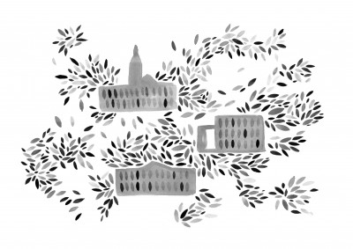 |  |  | What Diversity agent course?  Diversity agent course was part of the project Avaus – Opening. Becoming an agent in the field of arts and culture in Finland. The course was targeted for cultural workers and artists of non-Finnish origin or background. The course was organized together by Globe Art Point, Culture for All Service and Center for cultural policy research Cupore. The project was funded by Finnish National Agency for Education and it lasted until end of the spring 2020.  The aim of the course was to offer tools for developing diversity in the arts and culture sector. The course introduced participants to topics related to diversity, familiarized with the arts and culture sector and cultural policy in Finland and offered an opportunity to work concretely with diversity in an institutional context.  There were 11 arts and culture professionals participating in the course. They were selected through an open call procedure in March 2019 and they graduated in December 10, 2019.  "As Diversity Agents, we recognize the inherent value of diversity of all forms within art and culture institutions. We also identify the intersectionality and different interpretations of the concept of diversity. Much more than a buzzword, diversity encompasses a radical way to rethink administration, management, curatorial process, content, language, workspace and public engagement.”  ”Sitaatti!

