# AVAUS – DIVERSITY INFORMATION PACK





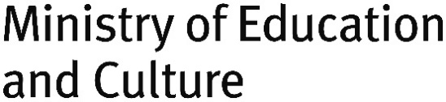

Avaus – Diversity Information Pack

Publications of Culture for All Service 4/2019

**Writer:** Martina Marti

**Publisher:** The Culture for All Service/ The Association For Culture on Equal Terms

**Translation:** Razan Abou Askar

**Illustration and graphic design ©:** Alexandra Burda, [alexandraburda-illustration.com](https://alexandraburda-illustration.com)

**Edition:** 100 copies

**Printing house:** aDigi Oy, Helsinki 2020

2. revised edition, 2020

ISBN 978-952-6677-64-4 (paperback, English)

ISBN 978-952-6677-65-1 (PDF, English)

ISBN 978-952-6677-66-8 (DOCX, English)

ISSN 2341-913X



The text of this publication is licensed under the Creative Commons Attribution-NonCommercial-NoDerivatives 4.0 International License. To view a copy of this license, visit [creativecommons.org/licenses/by-nc-nd/4.0](https://creativecommons.org/licenses/by-nc-nd/4.0/deed.fi)

The pictures and graphic design of this publication are not under Creative Commons license. They are subject to copyright.

Content

AVAUS-DIVERSITY INFORMATION PACK 1

Avaus - Opening 4

Becoming An Agent In The Field Of Arts And Culture In Finland 4

What Is Diversity? 5

Cultural Diversity in the Avaus Project 5

What Is It About? Inclusion! 7

The 4 Steps Of Change 8

Recognizing – Understanding - Will For Change - Making 8

2. Understanding. 8

3. Will for Change. 9

4. Making. 9

Cultural Diversity In Numbers 9

Proportion of foreign-born residents (2017) 9

Proportion of residents with foreign background in the 15 sub-regional units with most inhabitants on 1 Jan. 2018 (Source: Statistics Finland) 10

Residents with foreign background, residents with a foreign mother tongue and foreign nationals in Helsinki on 1 Jan 1991–2018 (source Statistics Finland) 10

Who Is Your Work Relevant For In The Light Of The Statistics Above? 11

Unesco Universal Declaration On Cultural Diversity (Article 2, 2001) 11

Constitution Of Finland, 6 § Equality 12

Non-discrimination Act, 9 § Positive action 12

What do we mean when we talk about equality? 12

What is Racism? 13

Homework 15

Try to respond to these questions and discuss your responses within your work community. 15

Norms in Diversity Work 16

Levels of Diversity within Organizations 16

First Level: Resistance to diversity 16

Second Level: The Promotion of Equal Treatment and Elimination of Discrimination on the Basis of Law 16

Third Level: Exploiting Diversity 17

Fourth Level: Integrating Diversity and Learning From It 17

What Can You Do? 18

Familiarize Yourself with These Concepts! 18

Expert Bodies 20

Reading List 23

Please note: This is the accessible version of Avaus – Diversity Information Pack. The page numbers are not the same as the page numbers of the PDF version.

# Avaus — Opening

## Becoming An Agent In The Field Of Arts And Culture In Finland

Avaus (Opening) was a project carried out in 2017–2020 supporting the employment of non-Finnish born artists and cultural professionals in Finland. The Culture for All Service implemented the project in cooperation with the Center for Cultural Policy Research Cupore and Globe Art Point ry. The project was funded by the Ministry of Education and Culture. The project carried out research on how cultural diversity is taken into account within the Finnish arts and culture sector, organises trainings and produces educational materials.

[www.kulttuuriakaikille.fi/en](http://www.kulttuuriakaikille.fi/en)

[www.cupore.fi/en](http://www.cupore.fi/en)

[www.globeartpoint.fi](http://www.globeartpoint.fi)

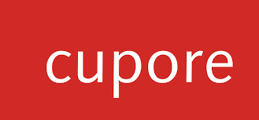



This information pack is intended for everyone who is interested in diversity and wants to promote equality within the field of arts and culture.

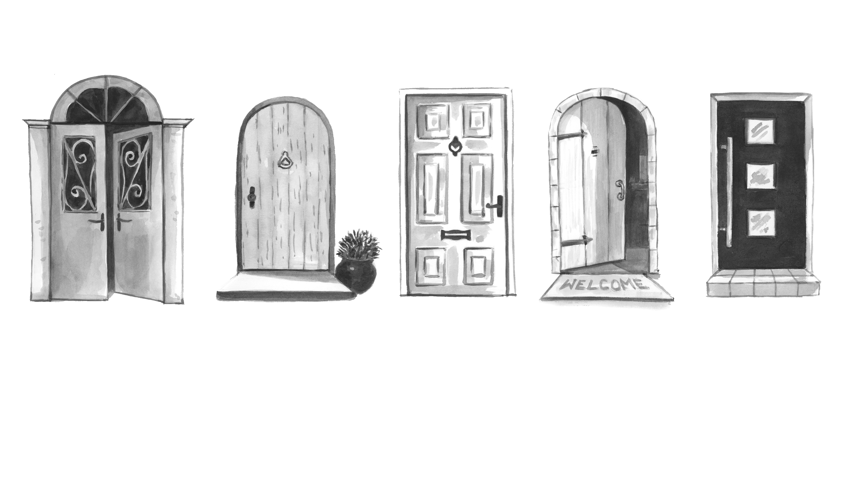

# What Is Diversity? ­

Diversity means that every person has innumerable qualities and roles, and that many of us belong to different groups. It can also be a so-called internal diversity, influenced by each individual’s own background and identity questions. The diversity of society includes all minority groups. Characteristics, backgrounds and groups may relate, for example, to gender, sexuality, socio-economic status, age, physical characteristics, disability, appearance, religion, language, cultural differences, ethnic backgrounds, political views, or different ideologies and beliefs. Taking diversity into account is about respecting the differences in the identity of a person in a safe and positive atmosphere. Everyone should feel welcome and respected as they are. It is important that everyone can participate without fear of discrimination.

## Cultural Diversity in the Avaus Project

The Avaus project’s aim is to promote the employment of non-Finnish born artists and cultural workers. By this we mean artists and cultural workers who live permanently in Finland but

* who were not born in Finland and
* whose native language is another than Finnish or Swedish and
* who have obtained their education or professional experience elsewhere than in Finland and
* who came to Finland either voluntarily or non-voluntarily.

For the above reasons these professionals don’t have equal opportunities to access and participate as makers in the Finnish arts and culture field.

Also Finnish-born artists and cultural workers can experience the same kind of obstacles to equal access to work opportunities in the arts and culture field. The project therefore does not exclude Finnish-born artists and cultural workers

* whose one or both parents are non-Finnish born or have a non-Finnish cultural background and/or
* who despite their origin belong to a minority which does not have the same opportunities to access and participation as the mainstream population (e.g. Sami, Romani or other racialized groups) and/or
* who have obtained their education or their professional experience elsewhere than in Finland.

## What Is It About? Inclusion!

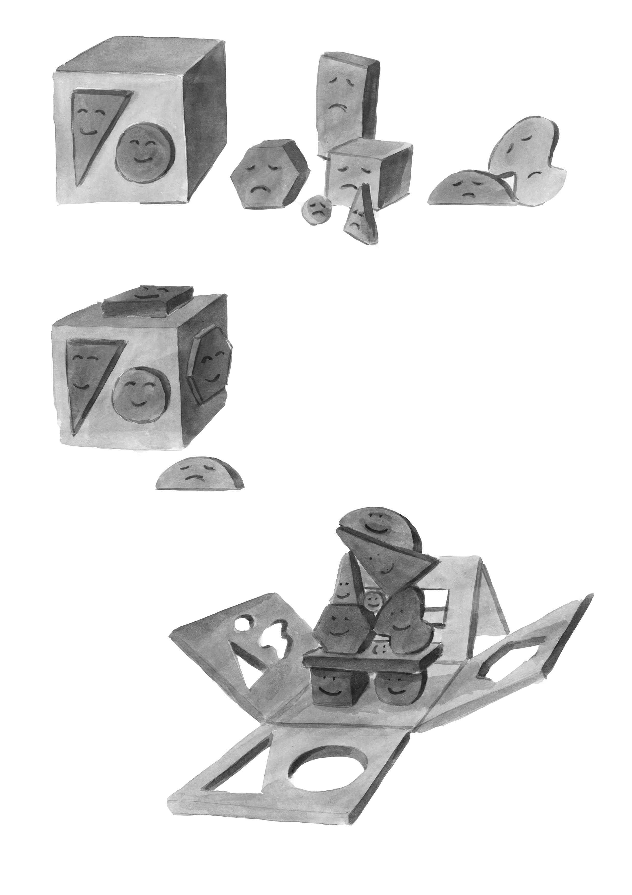

This wooden box, a familiar children’s toy, has holes of different shapes and sizes. Some of the blocks fit through the holes in the box. The blocks that got inside cry out to the ones left outside: “What’s your problem? You just have to be yourself to get inside.”

Only when new openings are created, all kinds of blocks can fit inside. It is a matter of inclusion; it’s about different people being able to enter the arts and culture field, arts and cultural institutions or artistic working groups, to produce artistic content and to find employment in a wide range of different positions. Existing doors, even if open, do not necessarily let everyone in. Creating new openings means taking into account the diversity of newcomers, such as linguistic or cultural diversity.

However, regardless of how many different openings are created, someone is always left outside. The abundance of diversity cannot be predicted.

Can your organization, project or artistic work be opened up in some other way? Can the making of art and cultural work be thought of in a completely new way and by doing so; can you create space for new people and new ways of doing? This is when something unexpected and yet unknown can happen.

# The 4 Steps Of Change

(Source: Malin Gustavsson, Ekvalita Oy)

## Recognizing – Understanding - Will For Change - Making

1. **Recognizing.** In the process of change, the first step is mapping the situation: what does our organization, working group or project look like right now? At this stage, we also need to familiarize ourselves with facts and statistics and, in general, start a debate about diversity.
2. Understanding. In the second stage, we must seek to understand why exclusion happens and how it happens. Why does our organization, working group or project look like it does today? What are the possible obstacles? Why are certain people left outside?
3. Will for Change. After understanding, we need the will for change, that is, the will to challenge the limits and habits of our own organization, work or project. Are we ready to do things differently? Only after this can we begin to make a change. Advisably this should start from where change is the easiest. It is important to maintain a conversation about diversity and continually evaluate what is being done, because it is through this that learning takes place.
4. Making. The process as a whole is dynamic, meaning that it is constantly in motion; it is always possible to go back in the process if needed. When we are making a change, mistakes also happen, and we find that we have not recognized or understood everything. But it is through the errors that we learn and succeed better the next time.

# Cultural Diversity In Numbers

### Proportion of foreign-born residents (2017)

Graph 1. In Helsinki the number of foreign-born residents is 14 percent of the entire population while 86 percent are Finnish-born.
Overall in Finland the number of foreign-born residents is 6,8 percent and the Finnish born population is 93,2 percent.


(Source: <http://kototietokanta.stat.fi>)

### Proportion of residents with foreign background in the 15 sub-regional units with most inhabitants on 1 Jan. 2018 (Source: Statistics Finland)

Graph 2. In Helsinki the number of residents with foreign background reaches 14%
In Turku it is 9%, in Kotka-Hamina 8%, in Vaasa 7,2%, in Lappeenranta 6,5%, in Tampere and Lahti 5,3%, in Hämeenlinna 4,3%, in Jyväskylä and Kouvola 4,2%, in Joensuu 3,9%, in Oulu 3,5%, in Kuopio 3,4%, in Pori 3%, Seinäjoki 2,2%.


### Residents with foreign background, residents with a foreign mother tongue and foreign nationals in Helsinki on 1 Jan 1991–2018 (source Statistics Finland)

Graph 3. The numbers of residents with foreign background, residenst with a foreign mother tongue and foreign nationals in Helsinki are all rising since 1991. Since 2005 the curve of  residents with a foreign mother tongue is steepest. There were 89,878 residents with foreign background in Helsinki at the beginning of 2016, which was 14.3 per cent of the total city population. 83 per cent of
them (74,308 persons) were born abroad and 17 per cent (15,570) in Finland.
In total, 81,998 Helsinki residents were born abroad but some of them had a
Finnish background.


Population with a foreign mother tongue in the Helsinki region on 1 Jan 2000–2018 and a projection for 2035Graph 4: By 2030 the number of population with a foreign mother tongue in Helsinki is estimated
to grow to 164,000–170,000 people, or about 23 per cent of the total population.
In the Helsinki Region there would be 350,000 foreign-language speakers, making up about 21 per cent of the total population. 

(Source: The projection for the population with a foreign mother tongue in Helsinki and the Helsinki Region 2018–2035, City of Helsinki)

## Who Is Your Work Relevant For In The Light Of The Statistics Above?

”It has never been more necessary to rethink the paradigms of what institutions understand by culture and the way they convey that to the public. The public’s shift in profile due to migration demands new reflections from the art institutions in regard to all their spheres: employment policy, their programs, and their staff, if they want to remain relevant for a changing population.”

B. Mandel (2016) quoted by Lorena Vicini, Decolonizing cultural management: propositions for shifting times, Observa Sur, UNESCO, 2017

### Unesco Universal Declaration On Cultural Diversity (Article 2, 2001)

Policies for the inclusion and participation of all citizens are guarantees of social cohesion, the vitality of civil society and peace. Thus defined, cultural pluralism gives policy expression to the reality of cultural diversity. Not dissociable from a democratic framework, cultural pluralism is conducive to cultural exchange and to the flourishing of creative capacities that sustain public life.

### Constitution Of Finland, 6 § Equality

“Everyone is equal before the law.

No one shall, without an acceptable reason, be treated differently from other persons on the ground of sex, age, origin, language, religion, conviction, opinion, health, disability or other reason that concerns his or her person.”

### Non-discrimination Act, 9 § Positive action

“Proportionate different treatment that aims to promote de facto equality, or to prevent or remove the disadvantages attributable to discrimination, does not constitute discrimination.”

# What do we mean when we talk about equality?

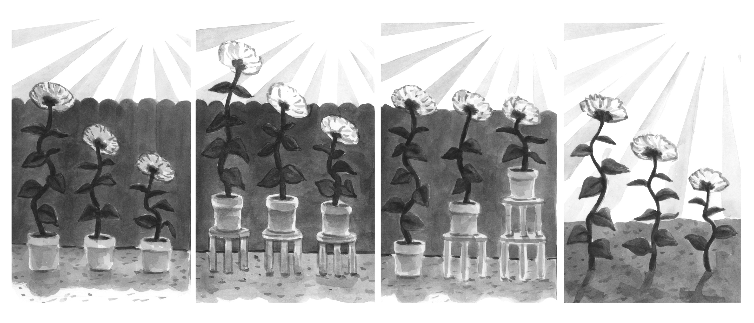

1. You see three sunflowers in their pots. The flower on the left is the longest and can reach over the edge of the fence to gain vital sunlight. The other two flowers grow slower and remain behind the fence in the shade. What would be the solution to this situation?
2. Give each flower its own stool. This is fair because every flower gets the same support. Now also the middle flower crosses the edge of the fence and gets into the sunlight. But the stool doesn’t help the flower on the right side, which remains in the shadow. Would there be another solution to this?
3. Give the stool of the longest flower to the shortest flower. What does this solution look like? Now all flowers reach the vital sunlight. This describes what is called de facto equality or equity. For such solutions, Finland has the Non-discrimination Act, according to which such individual, proportionate treatment is not discriminatory. The longest flower does not suffer from the shortest flower receiving two stools. But is there still another solution?
4. What if the fence is removed completely? All the flowers now get the same amount of sunlight. And what if even the pots are taken away? Now the flowers can root properly in the ground. What does this look like?

Of course, equality work is not about flowers, but about people, and the sun can be thought of as culture, which we all need in order to flourish.

# What is Racism?

“Racism isn’t the opinion of a certain person towards a certain group of people, but racism is a network or structure by which we build spaces, societies and states.”

Necati Öziri, German playwright and dramaturge

Racism, like other forms of discrimination, arranges spaces according to certain norms. Also the arts and culture field is made up of spaces that are arranged in certain ways. There are physical spaces that tell us who art and culture exist for: which languages are spoken in these spaces, who is working there, who are the toilets reserved for, what food and drinks are available.

The arts and culture field is also made up of mental spaces. There is a mental image or a mental concept of what – let’s says a museum, theatre, concert hall or gallery is like. These mental images are partly formed through history and the historical development of art disciplines, but also by prejudices and pre-defined concepts. In the field of arts and culture, these mental images may be related to, for instance, the myth of the artist as a strange and chaotic genius, to artistic conventions, the role of art in society, and in general the concepts of the artist and art. Also, the vision of art as autonomous and universal, theatre as political, museums as neutral or the state as objective or faceless is part of this mental space. Mental images should be recognized as mental images and not be perceived as facts. How could you expand your concepts of art, the artist and the arts institution with its mission?

Mental images change much more slowly than society does. How can each person in their own work stretch the idea of what they do and thus create real space for inclusion?

The arts and culture field has a particularly important role in creating inclusion, as identity is built on the basis of cultural heritage and by means of art. The Finnish national identity was deliberately built in the 19th century. This constructed identity was based on exclusivity: who is Finnish and who is not? Today we should create new narratives about who we are, and these narratives should be inclusive. How could you participate in building inclusive narratives and identity?

# Homework

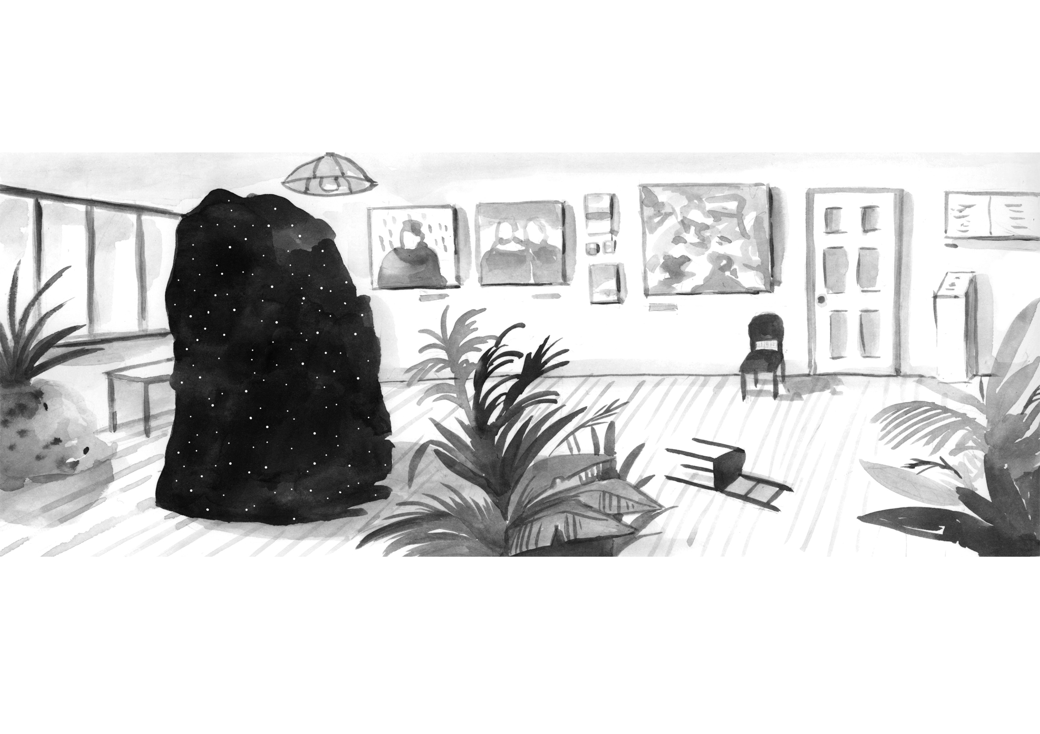

Discuss with your colleagues or working group how you define cultural diversity. Use the illustration above to inspire your discussion. What thoughts does the image arouse in you?

The image describes cultural diversity. Cultural diversity is part of our society, our houses, our institutions and our families. But how should it be approached? It’s a big black “something”, maybe scary but also interesting, even fascinating.

Cultural diversity is also a difficult term. By adding the adjective “cultural” in front of the word “diversity”, the impression is given that culture is something permanent we belong to: Finns form a homogeneous group and they are all a certain type - the same type. But culture is dynamic; it changes and evolves all the time. At the same time, every human being belongs to different groups and his or her identity develops and changes. Every human being is a whole universe.

## Try to respond to these questions and discuss your responses within your work community.

1. How do I benefit from being involved in cultural diversity?
2. How do I benefit from not being involved in cultural diversity?

## Norms in Diversity Work

Norms are predominant, but often invisible and unconscious ways to understand and perceive e.g. gender, ethnicity, Finnishness, art, etc. Norms often become concrete and visible only when someone deviates from them or breaks them.

What norms determine your organization’s activities, your project’s content or your art?

# Levels of Diversity within Organizations

(Source: Eva Rönkkö, Eläkeläiset ry)

## First Level: Resistance to diversity

The majority is afraid of losing its position and sees diversity as useless or as a threat (to its own or its organization’s operational culture). The challenges associated with diversity are ignored, but at the same time, the opportunities associated with it are also lost.

* there is no strategy
* “Diversity does not apply to us,” the values of the organization have not been discussed or have not been internalized
* the word “multiculturalism” may have been used but it is not a living reality, the basic strategy has not been opened and the staff has not been involved in it
* when conflicts / challenges arise, others are nullified and blamed, differences are explained by culture

## Second Level: The Promotion of Equal Treatment and Elimination of Discrimination on the Basis of Law

The organization aspires to meet the legal requirements to avoid discrimination, as well as to improve the labor market status and the use of services of minorities and marginalized individuals. Diversity is not given true value, instead, efforts are made to blend in minorities with the thought and action patterns of the majority.

* an equality plan has been made – it is stated what kind of and how many minorities exist in the local community or in the group of users
* the plan is made because of legal obligation but remains disconnected
* organization-oriented activity
* formal equality, own routines are maintained, there are no operational models that guarantee the de facto equality of minorities
* the plan is not followed, there is no reflection
* attitudes and fears are not openly discussed within the working community

## Third Level: Exploiting Diversity

Diversity is exploited and valued in marketing, sales and customer service from a utilitarian viewpoint, but there is no learning from it.

* there is a plan with measures in how to reach out to minorities
* “they” are targets, not active participants
* “Our Finnish customers do not accept or aren’t ready if they come here” - services and activities for minorities are separate from those for the main population
* project funding linked to diversity where the organization can benefit from it but change in the organization does not happen on all levels; diversity is outsourced to be handled by one person within the organization

## Fourth Level: Integrating Diversity and Learning From It

Diversity is seen as a resource for learning and change and is valued as a source for different perspectives, skills, experiences and innovation.

* in the equality plan, diversity has been considered from the point of view of both the work community and customers
* the organization’s activities have been defined so as to include diversity
* the management is committed to the promotion of the plan
* new ways of working, own activities are evaluated
* the work community is trained, employees are expected to develop their own cultural sensitivity
* in recruitment the demand for sensitivity and knowledge on diversity is explicit
* networking of actors and experts in the same field
* where possible, employees from minorities are recruited

Where is your organization, project or work positioned?

## What Can You Do?

1. Commit to diversity and equality in all activities.
2. Collaborate with artists and experts of non-Finnish origin or background, with minority communities as well as with their representative associations.
3. Promote employment opportunities, sharing of expertise and participation in decision-making for people belonging to minorities.
4. Develop your own, your staff’s or colleagues’ awareness of minority cultures, diversity and equality. Expand restrictive Western concepts of art, and thus allow for mutual learning and development.

## Familiarize Yourself with These Concepts!

1. **Cultural appropriation** means the borrowing, exploiting or stealing from a minority culture by the dominant culture without the consent from the minority culture. By doing so the dominant culture uses its power to exploit cultural elements such as objects, clothes, words, customs or visual material for its own purpose as a token of fun, for entertainment, as decoration or as a mascot, thereby trivializing the minority culture and / or ignoring the original meaning of the cultural object in the minority culture. Intentional or unintentional cultural appropriation does not respect the minority culture and can cause real damage to the minority culture. (Source: Panel Discussion, #StopHatredNow 2018, Charlene Teters, Pirita Näkkäläjärvi, Warda Ahmed)
2. **Norm criticism** is the criticism towards the prevailing norms of a society and the discriminatory practices arising from them. Norm criticism is the active practice of seeing things differently. Norms are invisible assumptions that are often taken for granted (e.g. norms related to gender, origin, social class, religion, sexual orientation, or functional ability). Norms are specific to their own time, their own culture and society, and can be challenged, contradicted, and made visible. A norm-critical perspective aims to dismantle normative assumptions and increase equality in society. (Source: Settlement Association, Multicultural Work)
3. **Ethnocentrism** refers to the experience that one’s own culture is a central and determining element in creating reality. It may mean that one’s own culture is perceived as the only true culture (possibly because there is no contact with other cultures) or that one’s own culture is perceived as the only good culture, or even as universal. The opposite of ethnocentrism is ethno-relativism, which means that the experience of one’s own culture stems from a context with multiple different cultures. Other cultures are valued and seen as equally complex as one’s own, different cultural contexts can be adapted to, or different perspectives and cultural worldviews can even be integrated into the experience of one’s own self. (Source: Handbook of Intercultural Training, 2004)
4. **Exoticism** refers to a perception of people coming from different cultures or of their culture as exotic. In this case, a Western worldview and value system is adopted through which non-Western cultures are seen and associations are made with mythical images based on a Western cultural framework and not on that actual culture in question. Although such “distant” places and cultures, as well as their representatives are perceived as mythical, beautiful, or even thrillingly strange, their culture is simultaneously identified with primitive and savage forms of civilization. In doing so, exoticism creates and strengthens stereotypes and images that reinforce the perception of Western culture as universal in relation to “other” cultures.
5. **Racialization** means that certain groups of people, such as immigrants or minorities, are represented as racial groups. Racialization can occur on the basis of skin color, cultural traits, religion, language or habits, and may appear, for example, in the form of hate speech or insulting writings. In Finland, for example Russians, Somalis, Sámi, Roma, or generally immigrants or minority groups have been subjected to racialization. As a result, such groups are trivialized and disrespected. (Source: Red Cross, [www.eirasismille.fi](http://www.eirasismille.fi))

# Expert Bodies

Cultural Center Caisa

[www.caisa.fi](http://www.caisa.fi)

The aim of Caisa Cultural Center is to support the tolerance and development of a multicultural city. The Caisa Cultural Center hosts, for example, different cultural events.

Catalysti

[www.catalysti.fi](http://www.catalysti.fi)

Catalysti – is an association of trans-cultural artists in Finland.

Globe Art Point ry

[www.globeartpoint.fi](http://www.globeartpoint.fi)

Globe Art Point is the center of knowledge and activity of foreign professional artists living in Finland, with the task to promote equality and integration in the Finnish arts and culture field in cooperation with other organizations and institutions.

Infopankki

[www.infopankki.fi](http://www.infopankki.fi)

Infopankki (i.e. Info Bank) is a website where you can find information about moving to Finland and living in Finland in more than ten languages.

Interkult Kassandra

[www.kassandra.fi](http://www.kassandra.fi)

Interkult Kassandra (Kassandra ry) is a nationally operating cultural association dedicated to promoting interculturalism through art and culture. In Interkult Kassandra’s activity, interculturalism and multiculturalism are ordinary things—norms in modern society.

Global Music Centre

[www.globalmusic.fi](http://www.globalmusic.fi)

The Global Music Centre is one of the Finnish music institutes. Its mission is to acquire and disseminate information about different music around the world in many different ways. The page includes a list and an introduction to immigrant musicians and their ensembles, Immigres, maintained by the Institute.

Moniheli ry

[www.moniheli.fi](http://www.moniheli.fi)

Moniheli is a cooperation network for multicultural organizations, with the aim of promoting the development of a multicultural and diverse Finnish society and to support the activities of member organizations in many different ways.

Startup Refugees

[startuprefugees.com/](https://startuprefugees.com/)

Startup Refugees is a non-profit volunteer network whose activities support the employment and entrepreneurship of asylum seekers.

Familia Club ry

[www.familiaclub.fi](http://www.familiaclub.fi)

Multicultural Association Familia Club ry is a meeting place for both Finns and foreigners. An important objective of their action is to support the preservation of one’s own culture and language, as well as to mitigate prejudices based on xenophobia and intolerance.

The Museum of the African Diaspora

[www.moadsf.org](http://www.moadsf.org)

The Museum of the African Diaspora is an international museum that collaborates extensively with various institutions. The museum focuses on the African diaspora.

Rasisminvastainen tutkijaverkosto / Anti-racist research network RASTER

[www.utu.fi/fi/sivustot/raster/Sivut/home.aspx](https://www.utu.fi/fi/sivustot/raster/Sivut/home.aspx)

Anti-racist research network (Raster) brings together researchers interested in demarcation, practices and structures related to racialisation, racism and ethnicity.

Sivuvalo - Onko tämä suomalaista kirjallisuutta?

[sivuvalo.com/suomi](https://sivuvalo.com/suomi)

Sivuvalo - Is this Finnish literature? is a multicultural project that seeks to highlight the work and views of poets and writers living in Finland but writing in languages other than Finnish or Swedish.

Suomen Pakolaisapu

[www.pakolaisapu.fi](http://www.pakolaisapu.fi)

Finnish Refugee Aid supports refugees and immigrants to work actively in everyday life and as members of society.

Museum of Impossible Forms

[museumofimpossibleforms.org](https://museumofimpossibleforms.org)

The Museum of Impossible Forms is a platform for multi-artistic and multidisciplinary encounters, as well as a space where one can learn, formulate identity structures, and think critically. A library and archive are at the heart of action.

Sahwira Africa International - Sawi

[sahwira-africa.org](https://sahwira-africa.org)

SahWira Africa International is an organization that works for the rights of women and girls, as well as fights against racism, poverty and violence.

Urbanapa

[urbanapa.fi](http://urbanapa.fi)

UrbanApa is an urban art community founded in 2010 by the Helsinki-based artists Sonya Lindfors and Anniina Jääskelinen (Murha collective) that produces a variety of events such as stage performances, art hatcheries, clubs, music festivals, site specific performances and workshops.

Turvapaikanhakijoiden tuki Tutu ry

[www.facebook.com/tutuyhdistys](http://www.facebook.com/tutuyhdistys)

Support for asylum seekers is an association whose volunteers organize clothing and integrative activities for asylum seekers.

Vammaisten maahanmuuttajien tukikeskus Hilma

[www.tukikeskushilma.fi](http://www.tukikeskushilma.fi)

Hilma Support Center for Migrants with Disabilities offers advice and guidance; information on rehabilitation, study, work and hobby opportunities; information and education material on the rights and situation of immigrants with disabilities in Finland, as well as consultation and training for organisations and authorities.

Väestöliiton monikulttuurinen osaamiskeskus

[www.vaestoliitto.fi/monikulttuurisuus](http://www.vaestoliitto.fi/monikulttuurisuus)/

The goal of the Multicultural Expertise Center of the Population Federation is to develop and influence family-based integration.

Yhdenvertaisuusvaltuutettu / Non-Discrimination Ombudsman

[www.syrjinta.fi](http://www.syrjinta.fi)

The role of the Non-Discrimination Ombudsman (Yhdenvertaisuusvaltuutettu) is to promote equality and tackle discrimination. The Ombudsman is an independent and autonomous authority.

Framil ry

[framil.fi](http://framil.fi)

Framil is a centre of participatory arts in Southwest Finland. Framil carries out community art projects, as well as provides participatory arts and nursing services to various communities and organizations.

Ruskeat Tytöt Ry

[www.ruskeattytot.fi](https://www.ruskeattytot.fi)

Ruskeat Tytöt (i.e. Brown Girls) is an association for brown people by brown people, whose goal is to expand representations in the field of culture, especially in the media, communications and literature, to normalize stories about brown people, and to serve as a platform for brown cultural professionals to carry out their own projects

# Reading List

Abu-Hanna, Umayya, Multikulti - monikulttuurisuuden käsikirja, Siltala 2012.

Ahmed, Sara, Tunteiden kulttuuripolitiikka, suom. Elina Halttunen-Riikonen, Niin & Näin, 2018

Anderson, Benedict. 1991. Imagined Communities. Revised edition. London: Verso

Att störa homogenitet, red. Anna Furumark, Nordic Academic Press 2013.

Blackness & the Postmodern, ed. Sonya Lindfors, UrbanApa 2018.

<http://urbanapa.fi/wp-content/uploads/2012/10/Blackness-the-Postmodern-PREVIEW-VERSION.pdf>

Break the Norm! methods for studying norms in general and the heteronorm in particular. The Living History Forum, RFSL Ungdom 2009.

[www.includegender.org/wp-content/uploads/2014/02/BreakTheNorm.pdf](http://www.includegender.org/wp-content/uploads/2014/02/BreakTheNorm.pdf)

Chakrabarty, Dipesh (2000) Provincializing Europe. Princeton University Press.

Complying with Colonialism, Gender, Race and Ethnicity in the Nordic Region, ed. Suvi Keskinen, Salla Tuori, Sari Irni and Diana Mulinari, 2009.

Curating as Anti-Racist Practice, ed. Natalie Bayer, Belinda Kazeem-Kamiski, Nora Sternfeld, Aalto University publication series Art+Design+Architecture 4/2018.

Featherstone, Simon (2005) Postcolonial Cultures. Edinburgh: Edinburgh University Press.

Gilroy, Paul. 1993. The Black Atlantic. Modernity and Double Consciousness. Cambridge: Harvard University Press.

Hobsbawm, Eric J. and Terence O.

Ranger (eds.). 1983. The Invention of Tradition. Cambridge: Cambridge University Press.

Kenen historia? Raportti monipuolisen historiantutkimuksen, -opetuksen ja vuoropuhelun tilasta ja haasteista Suomessa HWB Report 3, 10/2018, Emma Hakala Iina Hakola Jenni Laakso (toim.)

[www.historianswithoutborders.fi/kenenhistoria](http://www.historianswithoutborders.fi/kenenhistoria)

Kohti yhdenvertaisempia kulttuuripalveluita, ed. Jaana Eskola, British Council 2013.

http://www.kulttuuriakaikille.fi/doc/monikulttuurisuus_kansio/Kohti_yhdenvertaisempia_kulttuuripalveluita.pdf

Löytty, Olli, Kulttuurin sekakäyttäjät. Esseitä. Teos 2011.

Modood, Tariq. 2007. Multiculturalism. A Civic Idea. Cambridge & Malden: Polity.

Moni osaa - työpaikkaosaaminen monikulttuurisilla työpaikoilla, ed. Minna Toivanen, Ari Väänänen, Anna-Leena Kurki, Barbara Bergbom, Auli Airila, Työterveyslaitos, 2018

[www.julkari.fi/handle/10024/136165](http://www.julkari.fi/handle/10024/136165)

Pöyhtäri, Reeta, Immigration and Ethnic Diversity in Finnish and Dutch Magazines, Articulations of subject positions and symbolic communities, University of Tampere, 2014

<https://tampub.uta.fi/bitstream/handle/10024/94932/978-951-44-9366-9.pdf?sequence=1>

Said, Edward W. (1995) Orientalism. Reprinted with a new Afterword. New York: Pantheon Books.

Saukkonen, Pasi, Kotouttaminen ja kulttuuripolitiikka, Tutkimus maahanmuutosta ja monikulttuurisuudesta suomalaisella taiteen ja kulttuurin kentällä, Kulttuuripoliittisen tutkimuksen edistämissäätiö, Cupore 2010

Saukkonen, Pasi, Multiculturalism and nationalism in Finland, Research on Finnish Society Vol. 11 (2018), pp. 65-73

<http://finnresearch.fi/RFS2018_Saukkonen.pdf>

Saukkonen, Pasi, Ulkomaalaistaustaisten kotoutuminen Helsingissä 2016. Työllisyys, tulot, ja asuminen, Helsingin kaupunginkanslian Tutkimuskatsauksia 2018:3

[www.hel.fi/hel2/tietokeskus/julkaisut/pdf/18_12_18_Tutkimuskatsauksia_3_Saukkonen.pdf](http://www.hel.fi/hel2/tietokeskus/julkaisut/pdf/18_12_18_Tutkimuskatsauksia_3_Saukkonen.pdf)

Sosiaalinen kestävyys: asuminen, segregaatio ja tuloerot kolmella kaupunkiseudulla, Saikkonen Paula, Hannikainen Katri, Kauppinen Timo, Rasinkangas Jarkko & Vaalavuo Maria, Terveyden ja hyvinvoinnin laitos, Raportti 2/2018

[www.julkari.fi/bitstream/handle/10024/136125/URN_ISBN_978-952-343-084-6.pdf?sequence=1](http://www.julkari.fi/bitstream/handle/10024/136125/URN_ISBN_978-952-343-084-6.pdf?sequence=1)

Spivak, Gayatri Chakravorty (1996) Maailmasta kolmanteen. Engl. lähtöteksti Entering the Third World (1987). Suom. Jyrki Vainonen. Tampere: Vastapaino.

Toiseus 101 – näkökulmia toiseuteen, ed. Sonya Lindfors, UrbanApa 2016.

[www.kulttuuriakaikille.fi/doc/monikulttuurisuus_kansio/TOISEUS-101-nakokulmia-toiseuteen.pdf](http://www.kulttuuriakaikille.fi/doc/monikulttuurisuus_kansio/TOISEUS-101-nakokulmia-toiseuteen.pdf)

Vem får vara med? Perspektiv på inkludering och integration i kulturlivet i de nordiska länderna, Kulturanalys 2017.

[http://kulturanalys.se/wp-content/uploads/2018/02/Antologi_Vem-får-vara-med_webb.pdf](http://kulturanalys.se/wp-content/uploads/2018/02/Antologi_Vem-f%C3%A5r-vara-med_webb.pdf)

Lorena Vicini, Decolonizing cultural management: propositions for shifting times, Observa Sur 2017.

<http://observasur.org/wp-content/uploads/2017/10/Decolonizing-cultural-management-Lorena-Vicini.pdf>

Ahmed, Warda: Oletko tekemässä antirasistista projektia?, Ruskeat Tytöt, 2019

Onko rasismia ja/tai monikulttuurisuutta käsittelevä projektisi oikeasti antirasistinen, stereotypioita vahvistava tai jopa rasistinen? Tässä 14 kohtaa, joita on hyvä pohtia ennen projektin aloittamista.

[www.ruskeattytot.fi/rtmedia/https/wwwruskeattytotfi/rtmedia/oletkotekemassaantirasististaprojektia](http://www.ruskeattytot.fi/rtmedia/https/wwwruskeattytotfi/rtmedia/oletkotekemassaantirasististaprojektia)

Riksutställningar: Museerna och mångfalden. 2014.

[www.kulttuuriakaikille.fi/doc/undersokningar_och_rapporter/Museerna_och_mangfalden.pdf](http://www.kulttuuriakaikille.fi/doc/undersokningar_och_rapporter/Museerna_och_mangfalden.pdf)

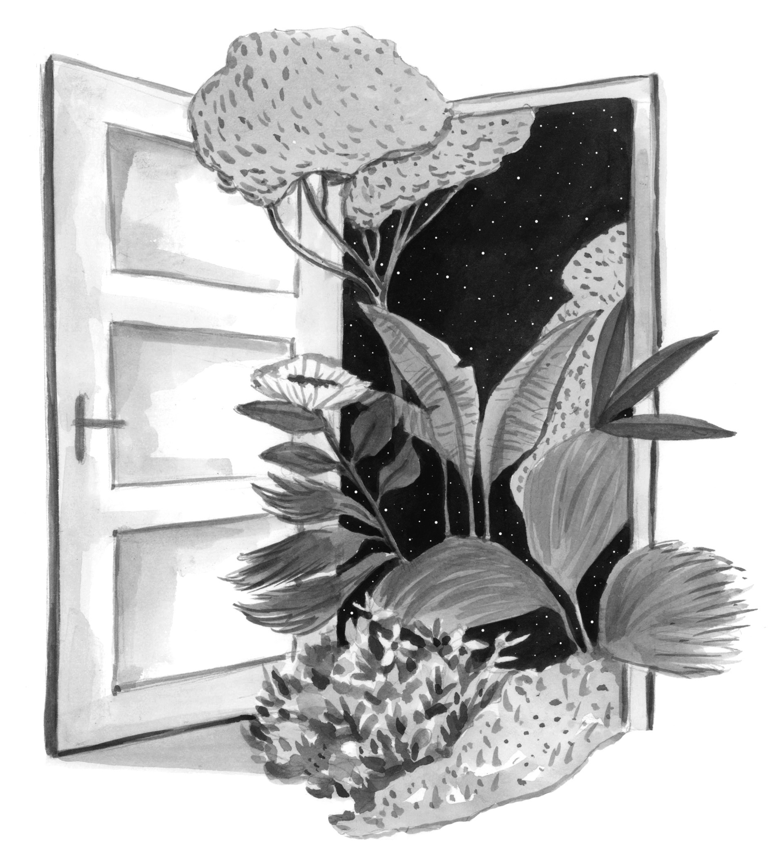

**The Culture for All Service**

The Culture for All Service supports the arts and cultural field in questions related to accessibility, diversity and equality and equity. We distribute information, organize trainings and discussions and coordinate different projects.

Contact: [www.kulttuuriakaikille.fi/about_us_contact_details](http://www.kulttuuriakaikille.fi/about_us_contact_details)