Let the Fingers do the Walking -
Three Dimensional Models for All

Julia Ionides and Peter Howell
The Dog Rose Trust
1.9.2008

Let the Fingers do the Walking
- Three Dimensional Models for All

When our blind colleagues and friends are asked what would help them most to understand a building or outdoor space, the reply is, ‘A tactile 3 dimensional scale model as it is the only way that the shape, size and architectural details can be appreciated’.

The key to successful projects is consultation. At Downpatrick, in Northern Ireland, we consulted with blind people from the local area at an early stage on the model of the old gaol which is now the museum and then met up with again when the model was finished to see what they thought of it.

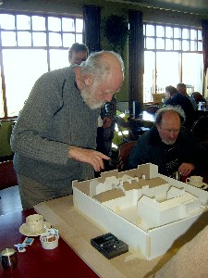
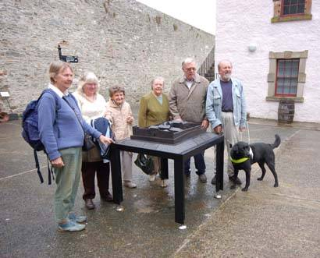
Consultation at Downpatrick and the finished bronze model

Each model needs a different approach; this can be influenced by the place where the model will be situated, the detail required and the client’s budget as well as other factors.

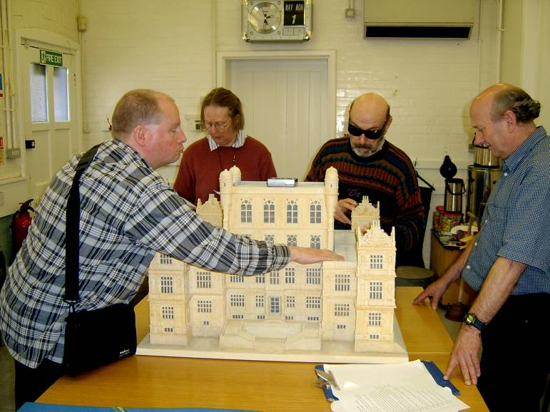

Blind consultants testing out the model of the historic house

Another important aspect is accompanying audio to guide the hands around the model and to know how blind people explore a model.

Consultation with the client on subjects other than price and materials, is also important, if only to agree what is possible and impossible. ‘No, the spire cannot be too pointed as that is dangerous if someone leans over it,’ is not popular with the purists, but a compromise has to be reached between aesthetics and safety.
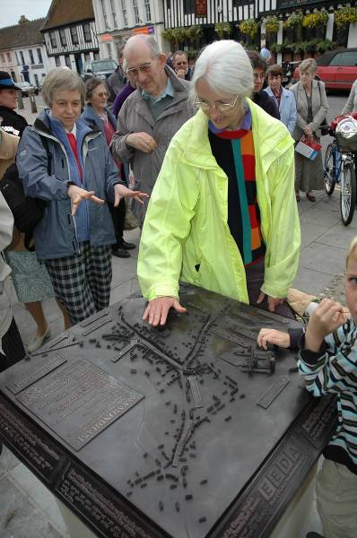
One bronze model we worked on was of a historic town that had a large and handsome abbey and during the consultation, a few houses had to be ‘demolished’ so that the streets could be widened for exploring fingers to get down the streets and read the Braille names.

The bronze model of the historic town completed, with the blind consultant on the right in the yellow jacket.

The choice of materials for the situation is also important: wood, resin or other man-made substance can be used indoors or in a controlled environment. However, for an outdoor uncontrolled situation the material must be more durable which is why we use bronze, although it is expensive. Other metals can be used with the lost wax process but there is little saving in the cost because it is a time-consuming process.

Case Studies
York - A Bronze Model
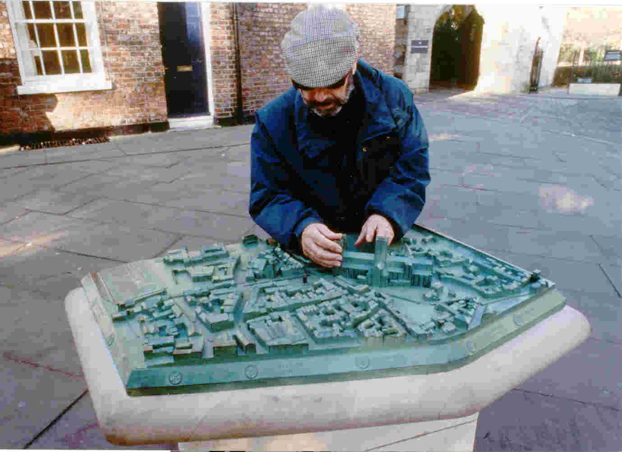

The bronze model of an area of the city of York

The model of the area of the historic city of York around the Minster (or Cathedral), the most prominent feature, was the first bronze model we made. The actual area covered is quite large and very densely packed with buildings, but the model itself could not be too large otherwise children and people using a wheelchair would not be able to reach the centre, a factor that needs to be considered.

The roofs of the medieval houses were modelled in the correct historic style which gave variation to the streetscape. The main historic buildings were modelled in more detail and their names put on a key in letters and Braille around the sloping base.

So that we could understand which streets to make prominent in a network of small streets, we conducted a telephone survey of members of the Blind and Partially Sighted Society. We asked them what routes they used to get into the city and gave prominence to those they used most. We asked them what landmarks or sounds they navigated by and many of them used the smell from ‘Thomas the Baker’ to find the post office.

The model maker came down with the wooden model in loose sections and tested it out with the group who made helpful suggestions about the width of streets and where they could or could not get their hands. An area of York was redesigned in an afternoon.

Next came the audio guide and again we consulted the members of the society. The audio guided the hands around the model and gave sensory and historical information about the city. To accompany the audio guide, A4 tactile maps with a key were designed by our graphic designer and produced by Tactile Vision of Canada.

The bronze has worn well with one or two scratches on it and what looks like a cigarette lighter burn. One of the York historical societies uses the model to show school children the layout of the city. You can see which the most popular buildings are as the patina is wearing away and the bronze colour coming through.

Maintenance is required for all models and plans outdoors; putting your fingers into wet dirt is not pleasant. Consult with the producer of the model or plan on the best methods of cleaning that will not do damage. Once the model has been handed over, with information about maintenance such as who to contact for repairs and other details, it is up to the client to look after it.

The Palace of Westminster – a wooden model

For a historic interior such as the Palace of Westminster in London, better known as the Houses of Parliament, only wood was suitable, especially as the model would be in the Robing Room where the Queen puts on her State Robes and Crown before opening Parliament each year.
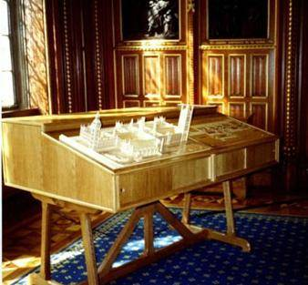

The wooden model of the Palace of Westminster

Such a large building required a large model, but as it was long rather than wide the question of reach did not really become a problem. The three dimensional mode of the whole building stands alongside the raised plan of the route that visitors take when they are on a tour; this is known as the Line of Route. The Queen follows this when she opens Parliament, but for historical reasons she only goes as far as the Lord's Chamber; other
visitors will go all the way to the Commons Chamber. The tour guides use the model and plan to show all the visitors where they will be going. This is a good example of universal design.

The details on the elevations of the Palace are repetitive and the best solution was to cut them out by laser – an innovative idea nearly twelve years ago. Braille on the wood proved another problem to solve: this was done by drilling holes through the dots on the Braille paper printouts and putting in tiny brass pins. After many years of touching, repairs were done and new elevations cut out – again by laser. A coat of varnish has been applied and the labels for the names renewed.

The model has an interactive audio commentary which was recorded in the Palace on a Saturday when it was empty and quiet; each space sounds different and by recording there the acoustics were captured and then explained on the commentary.

New technology using computer aided design programmes and milling machines should help to bring the price of models down with the result that more people can afford to commission them. But in the end people such as the end-users are the most important part of any project and as the future is exciting – let’s take advantage of it.

And don’t forget to publicise your model when it is finished!

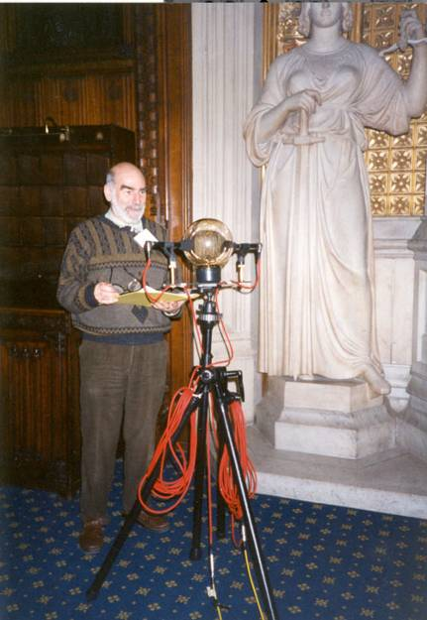
Recording the narration
in the Palace of Westminster

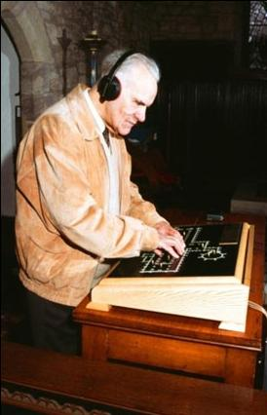

A blind consultant testing out an
interractive sound and touch system,
on a plan of York Minster. (Dorcas Project)

